**INTEGRATED HIGHER EDUCATION PLATFORM**

**Ministry of Education**

Integrated Higher Education Platform

Submitted By:

VERBANET TECHNOLOGIES L.L.C

**CONTENTS**

**1** **KEY DETAILS** 3

**2** **SCOPE OF WORK** 4

**3** **PROJECT SCOPE** 5

3.1 PROPOSED SOLUTION MODEL 6

3.2 FUNCTIONAL REQUIREMENTS 6

3.3 NON-FUNCTIONAL REQUIREMENT (OTHERS) 73

3.4 PROPOSED SYSTEM ENVIRONMENT 74

3.5 TECHNICAL CONFIGURATIONS 75

3.6 PROJECT DELIVERY 77

3.7 PROJECT ASSUMPTIONS 83

**4** **OUT OF SCOPE** 85

4.1 CHANGE MANAGEMENT 86

4.2 MAINTENANCE & SUPPORT 88

4.3 SERVICE LEVEL AGREEMENT (SLA) 88

**5** **TERMS & CONDITIONS** 90

5.1 ACCEPTANCE CRITERIA 90

5.2 WARRANTY 90

5.3 SOURCE CODE & INTELLECTUAL PROPERTY RIGHTS 90

5.4 GENERAL TERMS AND CONDITIONS 91

5.5 GENERAL ADMINISTRATIVE, TECHNICAL & FUNCTIONAL ASSUMPTIONS 92

**6** **FINANCIALS** 94

6.1 WEB AND MOBILE APPLICATION DEVELOPMENT 94

6.2 WINDOWS DEDICATED HOSTING – OPTIONAL 95

**7** **CLIENT REFERENCES** 96

**8** **ABOUT US** 99

# **KEY DETAILS**

**PROJECT NAME CLIENT**

Integrated Higher Education Platform Ministry of Education

**CLIENT CONTACT CLIENT ADDRESS**

Mr. P.O.Box 123

ABC Street

Dubai

U.A.E

**PROPOSAL SUBMISSION PROPOSAL ID NO.**

01.11.19  AD/BP/25042018/1820/2

**PROPOSAL VALID UNTIL ANTICIPATED START DATE**

30.11.19 00.00.00

**PROPOSAL SUBMITTED BY PROPOSED TECHNOLOGY**

Verbanet Technologies L.L.C ASP.NET Dubai, U.A.E **APPLICATION TYPE**

+971 4 297 3236 Web & Mobile Application

+971 50 765 2345

# **SCOPE OF WORK**

* Verbat will conduct an overall system requirement analysis to study all the processes, functions, policies, relationships, integration points, Cultural Attachés and procedures of all the MOEHEA departments
* Verbat will automate integration points and dependencies between MOEHEA’s departments
* Verbat will provide the best solution possible to integrate with external entities(MOF, MOI, ADEC, KHDA and others) without automating the processes or alter the systems of these entities
* Verbat will analyze all MOEHEA’s customer services in terms of service portfolio and fulfilment model by visiting MOE’s website
* Verbat will review the current IT eco system for MOEHEA to identify weaknesses and gaps and draw recommendations for the new systems.
* Verbat will provide a custom tailored mobile application
* Verbat will liaise with MOE’s IT department to finalize and deliver the technical and data center requirements
* Verbat will adopt a suitable fast-track methodology to deliver the integrated platform and will suggest a suitable phased approach

# **PROJECT SCOPE**

Integrated Higher Education Platform shall be developed to have a high-quality learning environment that enables generations of students to complete their higher education leading it to new horizons with the following features:

* Student Internship Journey
* Scholarship Student Journey
* University Journey
* Education Services Provider Journey
* Education Professional Journey
* Workforce Employee Journey &
* Shared Services Management process

Each of which has different functionalities:

* The Internship Journey consists of applying for an internship, study, graduate, continued support and stay engaged
* The Scholarship Journey consists of applying for scholarship, interviews, approval, receive Scholarship (logistics & travel, tuition & other payments), graduate, continued support and stay engaged
* The University Journey consists of applying for the license, quality assurance & compliance inspection, Pay, receive acceptance, receive a license (Initial Institutional License, Initial Program Accreditation), renew licensure/Program Accreditation, apply for substantial program change/Institution, Program Closure
* The Education Services Provider Journey consists of applying for the license, receive the license, renew the license, maintain the license status, Transfer/Cancel License
* The Education Professional Journey consists of registration, train, take an exam and receive the license
* The Workforce Professional Journey consists of Applying, evaluation and receiving equivalency statement
* The shared Services management process includes SLAs, deliver and review

Ministry of Education (hereafter referred to as “Client”) has approached Verbanet Technologies L.L.C., (hereafter referred under its trade/brand name as” Verbat”) to develop an Integrated Higher Education Platform to support MOEHEA business operation.

## PROPOSED SOLUTION MODEL

**STAND- ALONE FIXED BID**

Verbat will be following a stand–alone fixed bid solution delivery model wherein the required solution would be devised and a suitable pricing would be offered. Verbat’s solution architects have conducted a thorough research on the requirements and have come to the conclusion that our proposed solution, which is detailed further in this document, will meet the requirements put forth by the client.

**KEY STRENGTHS OF OUR SOLUTION**

* Strong and Scalable platform accommodating to future enhancements
* A framework which acts as a solution accelerator with building blocks that can be re-used in n future for building new components and features.
* Our light weight framework used consumes fewer system resources thereby making the application perform faster.
* All security aspects are considered

## FUNCTIONAL REQUIREMENTS

The main features and functionalities of the application to be developed are presented below:

### **Student Journey (Internship)**

* **Plan**

**Cascade Strategic Initiatives:**

* Student Journey Owner (JO) shall be assigned as per the set JO job description
* Cascade strategic initiatives and Higher Education strategy goals, and objectives to Registration and Student Counselling Department, Graduate and Labor Market Skills Department, and Scholarship Department and any other MoEHEA department involved in the Student Journey in order to incorporate them in the respective operational annual plans
* Student Journey KPIs based on Higher Education strategic priorities and previous cycle gaps to respective departments shall be developed & assigned

**Develop and Review Plans for Operations:**

* Solutions to previous cycle gaps identified in the lessons learnt session
* Annual plans needed for the delivery of the Student Journey shall include:
  + Student Communication Plan including student unified calendar, outreach and marketing plan for student awareness, roadshows for internships, annual calendar, and Data Collection Plan
  + Feedback Plan defining collection methodologies, timelines, and targeted groups of customers and internal and external entities
  + Secondary Education Equivalency Plan
  + Labor Market Needs Plan
* Supply-demand planning using historical data, exam results from EmSAT and acceptance criteria and inform universities shall be carried out
  + Operational requirements, including resources, shall be included in the Internal and External Entities Engagement Plan
  + Required SLAs shall be identified

**Develop Budget:**

* Annual costs based on – but not limited to – historical data, activities scheduled across the journey, and expected number of students that will apply through the unified portal shall be determined

**Set and Review Standards and Decision Structures:**

* Frameworks, guidelines and standards (e.g. secondary education equivalency guidelines, provisional acceptance standards, career counselling standards), and processes for student application shall be updated or set
* If needed decision structures and timelines related to the Student Journey shall be updated
* **Prepare**

**Engage with Internal and External Entities:**

* Engage with the following internal and external entities:
  + MoEHEA departments (Registration and Student Counselling Department, Scholarship Department, Graduate and Labor Market Skills Department, and Equivalency Department)
  + MoE General Education (School Operations Sector, Student Counselling Department, EmSAT Department)
  + MoE Shared Services through Shared Services Coordinators
  + External entities (school counsellors, university counsellors, career centers, training centers, alumni networks, partnered public and private employers, Higher Education Private Sector Council, KHDA, ADEK)
* Plans shall be realigned based on relevant entities communication and confirm understanding of their respective role
* New changes based on plans realignment shall be communicated to relevant internal and external entities

**Establish and Maintain Relationships with Internal and External Entities (e.g. SLAs/ MoUs/ Contracts):**

* SLAs, including the following as a minimum: MoE General Education and Shared Services shall be developed/updated
* MoUs, including the following as a minimum: public and private sector employers for tailored internships shall be developed/updated
* Contracts, including the following as a minimum: training centers and universities shall be agreed/updated
* Other agreements with relevant stakeholders shall be updated or developed

**Design and Develop Content:**

* Content for the Student Communication Plan, including, “single point of registration” information package for the unified portal shall be designed/updated
* All relevant Student Journey guidance and awareness materials (brochures, Graduate Destination Survey, Employer Survey, website content, etc.) and align on content and messaging shall be designed/updated
* Student Feedback Surveys shall be designed/updated

**Setup Resources Required:**

* Student application on the unified portal to enable the single point of registration based on the admissions criteria, equivalency reporting requirements, feedback regarding the application from previous years shall be setup/updated
* Internship opportunities on the unified portal shall be updated
* Hire resources and skills, as needed, to deliver the Student Journey
* Training shall be conducted for the following as a minimum: outreach representatives, school counsellors, and university counsellors
* **Awareness**

**Engage Student in Initial Phase:**

* Student Communication Plan including Student unified calendar dates, outreach and marketing activities shall be implemented
* Guidance material and FAQs shall be distributed
* Students across different channels (incl. roadshows, website, social media, online open day) shall be engaged with the goal of spreading awareness and information

**Provide Student Support:**

* Offer support to students (to be provided by outreach representatives, school counsellors, university counsellors and Happiness Center as per their respective training)
* Escalate and resolve issues to relevant departments where necessary

**Gather feedback**

* Gather feedback from students and internal and external entities to be used in monitoring, reporting and continuous improvement
* **Apply** **&** **Receive** **Acceptance**

**Launch Application Process:**

* Go live with student application for public universities on the unified portal
* Receive and manage application requirements and ensure completeness including digitized verification of result records from relevant entities (e.g. KHDA), digitized verification of EmSAT scores
* Conduct secondary degree equivalency for students who studied in private schools or abroad
* Verify applications of students and categorize them into buckets for initial indication to universities/programs (i.e. qualifies, partially qualifies, does not qualify) which facilitates filtering and screening of students by universities
* Manage tracking mechanism to inform students of application status (complete or incomplete) throughout the process

**Provide Provisional Acceptance:**

* Manage student applications as per set admission standards
* Support universities to communicate provisional-acceptance to students and update status of online application
* Update status of application to provisional-acceptance based on university provisional decisions

**Form Final Decision:**

* Support universities to collect final documents to issue final decision
* Receive universities’ decisions based on review of final school results against the provisional-acceptance
* Support universities to communicate final acceptances and update status of online application
* Consolidate list of final students and communicate to relevant internal and external entities

**Provide Student Support:**

* Offer support to students (to be provided by school counsellors, university counsellors and Happiness Center as per their respective training)
* Escalate and resolve issues to relevant departments where necessary

**Gather feedback**

* Gather feedback from students and internal and external entities to be used in monitoring, reporting and continuous improvement
* **Study, Receive support & graduate**

**Manage Student Affairs:**

* Provide information on scholarship opportunities for post-bachelor degree and provide information on labor market demand and post-bachelor degree specializations
* Inform students through university counsellors of any potential opportunities in and out the UAE (volunteer work, up skilling programs, internships, etc.)

**Identify Internship Opportunities for University Students:**

* Target university counsellors to encourage their students to participate in internship opportunities secured by MoEHEA MoUs
* Conduct roadshows for students to get in contact with employers for potential internships
* Ensure the internship opportunities on the unified portal are up to date

**Manage Degree Equivalency:**

* Manage degree equivalency for university degrees issued from private universities or abroad

**Provide Student Support:**

* Offer support to students (to be provided by university counsellors and Happiness Center as per their respective training)
* Escalate and resolve issues to relevant departments where necessary

**Gather feedback**

* Gather feedback from students and internal and external entities to be used in monitoring, reporting and continuous improvement
* **Stay Engaged**

**Engage Graduates:**

* Track graduate employment (through the Graduate Destination Survey)
* Engage existing university career centers and alumni networks to offer career guidance services to fresh graduates and alumni who delayed entering the workforce (family/national service reasons)

**Identify Internship Opportunities for Graduates:**

* Target fresh graduates and alumni who delayed entering the workforce (family/national service reasons) for internship opportunities through career centers and alumni networks, in order to support them in their transition to employment and ensure proper skilling
* Support university career centers to widen scope of outreach to employers and alumni regarding internship opportunities
* Ensure the internship opportunities on the unified portal are up to date

**Provide Opportunities for Continuous Learning:**

* Study labor market needs and strategy to identify subjects of interest
* Map out and communicate opportunities related to Skills Development and Ups killing Programs by offering short and accessible training courses aligned with labor market needs (different from academic programs offered at universities) through partnerships with training centers, universities and Massive Online Open Course providers
* Identify subjects of interest for continuous learning and target a wide range of students, including current students, scholarship students, fresh graduates, alumni, etc. through training centers, universities and Massive Online Open Course providers

**Provide Student Support:**

* Offer support to students (to be provided by career centers, training centers, universities and Happiness Center as per their respective training)
* Escalate and resolve issues to related departments where necessary (including Graduate and Labor Market Skills Department to provide support with regards to employment options/resources)

**Gather feedback**

* Gather feedback from students and internal and external entities to be used in monitoring, reporting and continuous improvement
* **Measure & Report**

**Gather and Analyze Data:**

* Gather and analyze feedback, as a minimum, from students, schools, universities regarding Student Communication Plan, Engagement Plan, application process, admissions support, internships, and alumni engagement
* Gather and analyze relevant statistics from the Student Journey to inform policies and decision making
* Analyze job market demand through Employer Survey
* Prepare findings reports and status updates relevant to the Student Journey

**Measure Performance:**

* Measure and monitor results of the delivery of activities against Student Journey KPIs/SLAs through regular reviews
* Review results of the delivery of the Student Journey

**Ensure Continuous Improvement:**

* Conduct lessons learnt sessions with relevant MoEHEA Departments
* Identify gaps in the Student Journey
* Put interventions in place, including action points for next cycle, to address underperformance and/or internal functional issues related to the Student Journey
* Mobilize additional resources where required
* Provide additional training and development activities where if required

**Report:**

* Prepare and provide reports relevant to the performance and outcomes of the Student Journey to support leadership in decision making. This may include but is not limited to reporting on:
  + Journey related KPIs
  + Satisfaction rates of students against key moments that matter (e.g. outreach plan, etc.)
  + Number of student applications received (3 year trend minimum)
  + Percentage of degrees positive secondary education equivalency statements
  + Percentage of students accepted into at least one of their top 2 choices (3 year trend minimum)
  + Percentage of incomplete applications out of the total application pool
  + Utilization of HE programs aligned to Labor Market Strategy
  + Total number of internships provided and total number completed in private sector by field
  + Graduate employment within 6 months by field (3 year trend minimum)
  + Shifts and trends in the UAE labor market and degree of alignment with the higher education sector
  + Satisfaction rate of employers with graduates by field (3 year trend minimum)

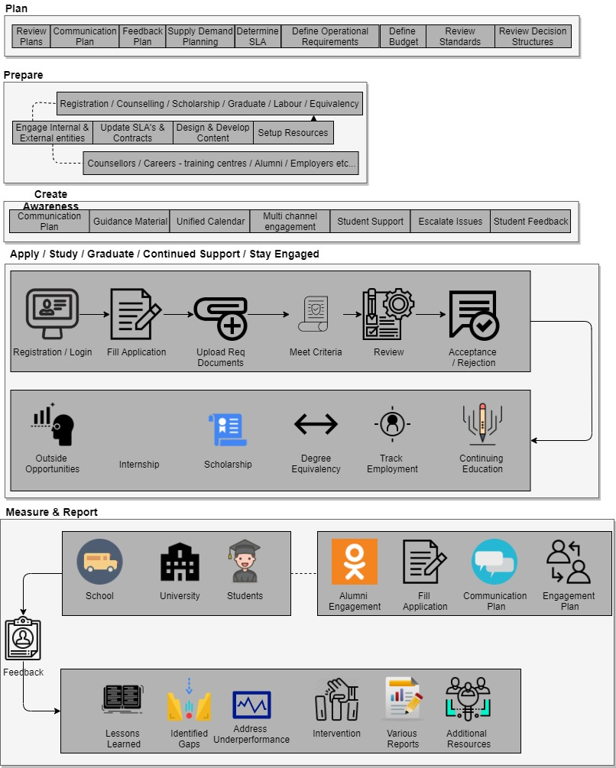**Student Journey Internship Workflow**

### **Scholarship Student Journey**

* **Plan**

**Cascade Strategic Initiatives:**

* Assign Scholarship Student Journey Owner (JO) as per the set JO job description
* Cascade strategic initiatives and Higher Education strategy goals, and objectives to Scholarship Department, Graduate and Labor Market Skills Department, Registration and Student Counselling Department and any other MoEHEA department involved in the Scholarship Student Journey in order to incorporate them in the respective operational annual plans
* Scholarship Student Journey ownership and KPIs to respective departments and overall journey KPIs to the respective JO shall be developed and assigned

**Develop and Review Plans for Operations:**

* Solutions to previous cycle gaps identified in the lessons learnt session
* Annual plans needed for the delivery of the Scholarship Journey shall be updated/developed which include:
  + Annual Scholarship Target Plan including countries, universities, specialties, and number of scholarships (reserved seats \ Open Admission seats \ Friendly Country)
  + Top-performers attraction plan
  + Scholarship Student Communication Plan including unified calendar, outreach and marketing plan for targeting top-performers and reserved seats
  + Counselling Plan including scholarship counselling (detailed information to customer about scholarship program) academic counselling (PhD faculty), emotional counselling (3rd party emotional counsellors) and peer mentoring (SHORIK students and ambassadors)
  + Pre-departure Orientation Plan including preparing and onboarding the new scholarship students
  + Alumni Engagement Plan including Annual Scholarship Forum, Scholarship Forum Website, alumni association, annual events calendar, communication channels, and mentorship program
  + Pre-approval Equivalency Plan
* Feedback Plan to define feedback collection methodologies, timelines and targeted groups from customers and internal and external entities shall be developed/updated
* Operational requirements, including resources, shall be included in the Engagement Plan
* Required SLAs shall be identified

**Develop Budget:**

* Annual costs based on – but not limited to – historical data, activities scheduled across the journey, number of active and graduating scholarship\students, and expected number of scholarship students that will apply through the unified portal shall be determined

**Set and Review Standards and Decision Structures:**

* Frameworks, guidelines and standards (e.g. pre-approval equivalency guideline, acceptance standards, career counselling standards), and processes for scholarship student application shall be set/updated
* Decision structures and timelines related to the Scholarship Student Journey if needed, including role of Scholarship Committee shall be updated
* **Prepare**

**Engage with Internal and External Entities:**

* Engage with the following internal and external entities:
  + MoEHEA departments (Scholarship Department, Registration and Student Counselling Department, Graduate and Labor Market Skills Department, and Equivalency Department)
  + MoE General Education (EmSAT Department)
  + MoE Shared Services through Shared Services Coordinators
  + External Entities (PhD faculty, third party emotional counsellors, SHORIK students, ambassadors, schools, universities outside the UAE, Higher Education Private Sector Council, career centers, training centers, and partnered employers, )
* Plans shall be realigned based on relevant entities communication and confirm understanding of their respective role
* New changes based on plans realignment shall be communicated to relevant internal and external entities

**Establish and Maintain Relationships with Internal and External Parties (SLAs/MoUs/Contracts):**

* SLAs, including the following as a minimum: Shared Services and EmSAT shall be developed/updated
* MoUs, including the following as a minimum: Private and public sector employers for tailored internships targeting scholarship students, and universities outside UAE based on national agenda plans and objectives to secure seats shall be developed/updated
* Contracts, including the following as a minimum: training centers, universities, Massive Online Open Course providers for up skilling programs, academic counsellors (through recruiting PhD faculty from federal universities) and third party emotional counsellors shall be agreed/updated
* Other agreements with relevant stakeholders shall be developed/updated

**Design and Develop Content:**

* “single point of registration” information package for the unified portal related to scholarships shall be designed/updated
* All relevant Scholarship Student Journey guidance and awareness materials (brochures, website content, pre-departure and re-integration orientation packages, Graduate Destination Survey – related to scholarships, etc.) and align on content and messaging shall be designed/updated
* Scholarship student contracts shall be designed/updated
* Scholarship student surveys (newly accepted scholarship students) and scholarship satisfaction surveys (active scholars in universities abroad on their level of satisfaction) shall be designed/updated

**Setup Resources Required:**

* scholarship student application on the unified portal to enable the single point of registration based on the criteria, equivalency reporting requirements, continuous monitoring, evaluation reports and updated content Shall be setup/updated
* Internship opportunities on the unified portal shall be updated
* Training shall be conducted for the following as a minimum: school counsellors, SHORIK students, PhD Faculty academic counsellors, and emotional counsellors
* **Awareness**

**Engage Student in Initial Phase:**

* Scholarship Student Communication Plan according to the unified calendar dates including, outreach and marketing plan for secured seats in the scholarship program shall be implemented
* Guidance material and FAQs shall be distributed
* Students and parents across different channels shall be engaged (incl. roadshows, website, social media) with the goal of spreading awareness and information
* Top-performing students for Scholarship opportunities shall be targeted through high school counsellors
* Attract and continuously support top-performing students to secure scholarship seats

**Provide Support:**

* Offer support and guidance to all parties relevant to the scholarship program (to be provided by scholarship counsellors, school counsellors, university counsellors, and outreach representatives as per their respective training)
* Escalate and resolve issues to related departments where necessary

**Gather feedback**

* Gather feedback from students and internal and external entities to be used in monitoring, reporting and continuous improvement
* **Apply & Receive acceptance**

**Launch Application Process:**

* Go live with scholarship application on the unified portal
* Receive and manage application (Reserved seats \ Open Admission seats\ friendly country seats) and ensure completeness of requirements
* Conduct pre-approval equivalency for applicant (open admission seats)
* Manage tracking mechanism to inform applicants of status throughout the process

**Assess Applicants and Issue Acceptance:**

* Apply standards and acceptance criteria and conditions
* Map applicants against set reserved seats and specialties
* Carry out the rule-based engine against universities’ criteria
  + Conduct interviews with potential applicants (if required)
  + Shortlist student application and create initial list
  + Coordinate with other scholarship providers in the Emirates to prevent overlap and duplication in application
  + Issue provisional-acceptance until conditions are met
  + Approve the final list by the Scholarship Committee & Minister
  + Confirm acceptance of final decision through the required contracts submitted by applicants
  + Update the status of the applications, communicate and publish the list with concerned parties
* Update the budget estimates to MoF
* Register students

**Provide Scholarship Student Support:**

* Offer support to scholarship students (to be provided by school counsellors, happiness center and academic advisor as per their respective training)
* Escalate and resolve issues to related departments where necessary

**Gather feedback**

* Gather feedback from students and internal and external entities to be used in monitoring, reporting and continuous improvement
* **Get On-boarded**

**Prepare Student for Scholarship:**

* Arrange and conduct pre-departure orientation
* Establish a communication channel between students, cultural attaché, academic counsellor, emotional counsellor, and SHORIK students

**Carry Out Needed Arrangements:**

* Communicate and arrange logistics and travel arrangements for scholarship students prior departure
* Process student tuition and other payments
* Through the Cultural Attaché
  + Communicate and arrange scholarship students affairs (insurance, housing, books, dependents)
  + Coordinate with the student upon their arrival on the following:
  + Communication channels throughout the journey
  + Information about student advisor in university, in country, and at home country
  + Touch points throughout the semester and progress form submission process and timeline

**Provide Scholarship Student Support:**

* Offer support to scholarship students (to be provided by Cultural Attaches and SHORIK students as per their respective training)
* Escalate and resolve issues to related departments where necessary

**Gather feedback**

* Gather feedback from students and internal and external entities to be used in monitoring, reporting and continuous improvement
* **Study, Receive support & Graduate**

**Manage Student Affairs:**

* Provide guidance and follow-up on scholarship student’s financial, social and health through regular meetings based on the agreed touch points
* Provide academic counselling to undergraduate scholarship students (through PhD faculty)
* Provide emotional counselling (through a third party)
* Provide administrative support (through Cultural Attaches)
* Follow-up and monitor scholarship students’ academic performance, progress and attendance
* Provide volunteer opportunities and internship opportunities for scholarship students
* Ensure the internship opportunities on the unified portal are up to date
* Manage non-credit internships and performance
* Facilitate payments, allowances and tuitions
* Manage student services (including all e-services provided by MoEHEA) based on the guidelines provided to the scholars
  + Ensure access to university records for each scholars
  + Develop a periodical report about student’s enrolment academic, health, social and financial status

**Manage Graduation:**

* Manage student clearance (including dorms, payments, return books) to ensure that there is no liability on student, university, or MoEHEA
* Settle financial entitlements of the scholarship student
* Manage and execute final travel arrangement
* Evaluate scholarship and scholars upon completion of the program
* Award top-performing scholars
* Manage equivalency of university issued degrees

**Provide Scholarship Student Support:**

* Offer support to scholarship students (to be provided by Cultural Attaches, PhD Faculty, third party emotional counsellors, and ambassadors (Peer to Peer) as per their respective training)
* Escalate and resolve issues to related departments where necessary

**Gather feedback**

* Gather feedback from students and internal and external entities to be used in monitoring, reporting and continuous improvement
* **Stay Engaged**

**Engage Graduates:**

* Implement Alumni Engagement Plan, including alumni association activities, annual events calendar, etc.
* Conduct the Annual Scholarship Forum to engage the current and graduated scholarship students
* Establish and update Scholarship Alumni Database and communication channels
* Track graduate employment (through the Graduate Destination Survey)
* Offer career center services and guidance to fresh scholarship graduates and alumni who delayed entering the workforce (family/national service reasons)

**Identify Internship Opportunities for Graduates:**

* Target fresh scholarship graduates who delayed entering the workforce (family/national service reasons) for internship opportunities through career centers and alumni networks, in order to support them in their transition to employment and ensure proper skilling
* Support career centers to widen scope of outreach to employers and alumni regarding internship opportunities
* Offer and manage potential internships at MoEHEA to promising scholarship graduates
* Ensure the internship opportunities on the unified portal are up to date

**Provide Opportunities for Continuous Learning:**

* Study labor market needs and strategy to identify subjects of interest
* Create an enablement environment to implement Skills Development and Upskilling Programs by offering short and accessible training courses aligned with labor market needs addressed by the Student Journey related departments (different from academic programs offered at universities) through partnerships with training centers, universities and Massive Online Open Course providers such as Coursera
* Target a wide range of students, which includes current scholarship students and promising scholarship graduates through training centers, universities and Massive Online Open Course providers

**Provide Scholarship Student Support:**

* Offer support to scholarship students (to be provided by career centers and training centers as per their respective training)
* Escalate and resolve issues to related departments where necessary (including Graduate and Labor Market Skills Department to provide support with regards to employment options/resources)

**Gather feedback**

* Gather feedback from students and internal and external entities to be used in monitoring, reporting and continuous improvement
* **Measure & Report**

**Gather and Analyze Data:**

* Gather and analyze feedback, as a minimum, from scholarship students, schools, universities, cultural attaches, academic and emotional counsellors regarding Scholarship Student Communication Plan, Engagement Plan, application and acceptance process, on-boarding, managing student affairs, support, and alumni engagement
* Gather and analyze relevant statistics from the Scholarship Student Journey to inform policies and decision making
* Prepare findings reports and status updates relevant to the Scholarship Student Journey

**Measure Performance:**

* Measure and monitor results of the delivery of activities against Scholarship Student Journey KPIs/SLAs through regular reviews
* Review results of the delivery of the Scholarship Student Journey

**Ensure Continuous Improvement:**

* Conduct lessons learnt sessions with relevant MoEHEA Departments
* Identify gaps in the Scholarship Student Journey
* Put interventions in place, including action points for next cycle, to address underperformance and/or internal functional issues related to the Scholarship Student Journey
* Mobilize additional resources where required
* Provide additional training and development activities where if required

**Report:**

* Prepare and provide reports relevant to the performance and outcomes of Scholarship Student Journey to support leadership in decision making. This may include but is not limited to reporting on:
  + Journey related KPIs
  + Satisfaction rates of scholarship students against key moments that matter (e.g. outreach plan, etc.)
  + Number of scholarship student applications received (3 year trend minimum)
  + Percentage of incomplete applications out of the total application pool
  + Total number of internships provided and total number completed in private sector by field
  + Graduate employment within 6 months by field (3 year trend minimum)
  + Satisfaction rate of employers with graduates by field (3 year trend minimum)
  + Total seats reserved by specialty, university and country
  + Percentage of seats filled out of total seats reserved
  + Percentage of students that receive seats at the top 50 international institutions
  + Percentage of degrees positive pre-approval equivalency statements
  + Projection reports for expected graduation rates
  + Employment rates among scholars within 6 months of graduation (broken by sector: Public, Private)

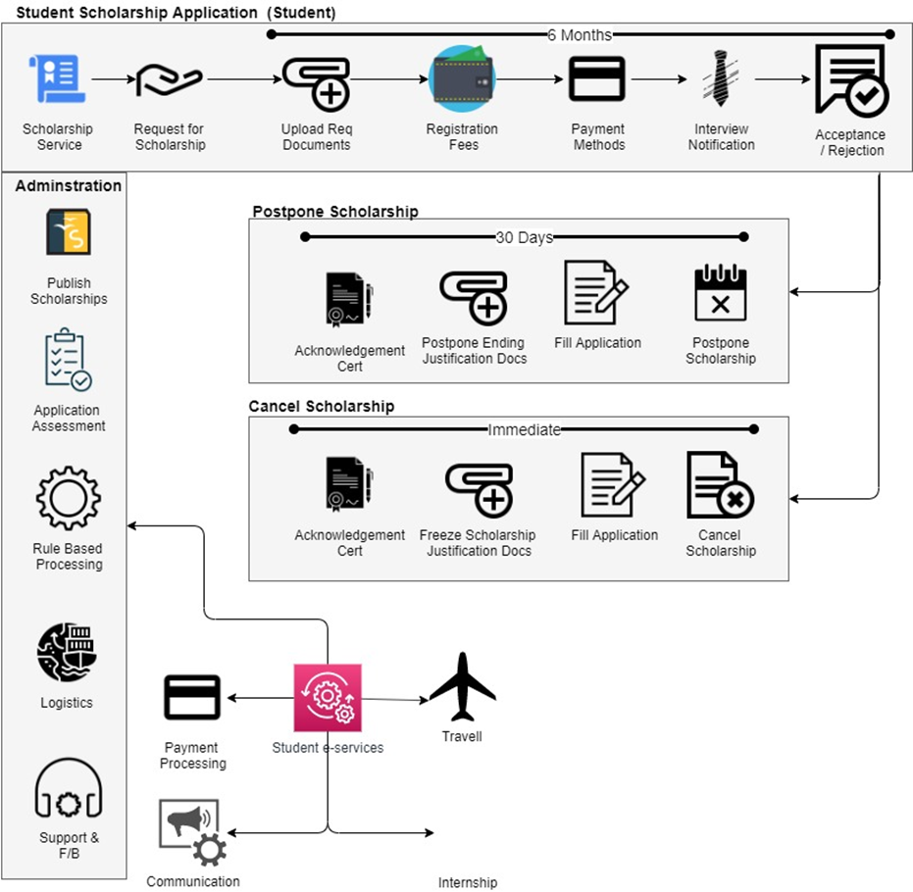**Scholarship Application Workflow**

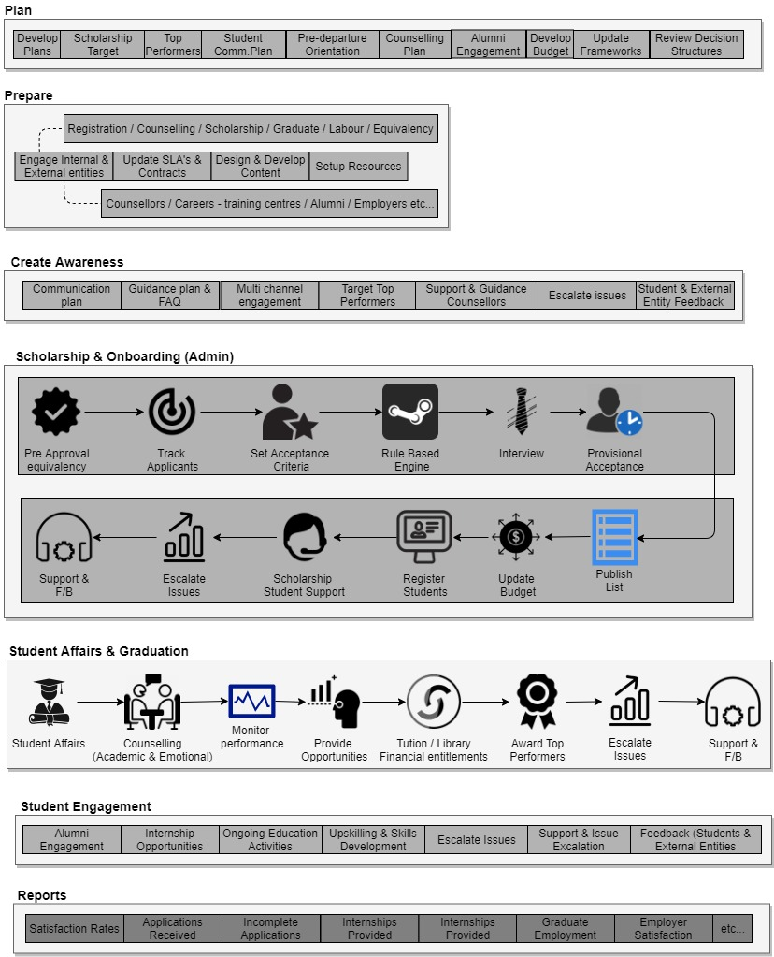**Scholarship Student Journey**

### **University Journey**

* **Plan**

**Cascade Strategic Initiatives:**

* Cascade strategic initiatives and Higher Education strategy goals, and objectives to CAA, Institutional Licensing & Accreditation Department (IL&A), Quality Assurance Department (QA) and Compliance and Inspection Department in order to incorporate them in the respective operational annual plans
* University Journey ownership and KPIs to respective departments and overall journey KPIs to the respective JO shall be developed and assigned

**Develop and Review Plans for Operations:**

* Annual plans needed for the delivery of the University Journey shall be developed which include:
  + Institutional licensing & re-licensing and program accreditation & re-accreditation plans including university visit calendar
  + Plan for quality assessment and classification of universities and formation of specialized teams
  + Plan monitoring and compliance inspection of universities, including university visit calendar
  + Strategic Research Plan to provide recommendations to the universities regarding which courses are most popular and what employers want
  + University Communication Plan to raise university awareness about
    - Requirements (for Initial Institutional Licensing (IIL), Initial Program Accreditation (IPA), Renewal of Institutional Licensure (RIL), Renewal of Program Accreditation (RPA), compliance inspection and classification)
    - Site visits
    - Interviews
    - Data Collection
    - Results of classification
    - Re-licensing and re-accreditation schedules
* Feedback Plan to define feedback collection methodologies, timelines and targeted groups from customers and internal and external entities shall be developed or updated
* Coordinate and consolidate clear and unified university calendar that schedules university site visits throughout the year for IIL. IPA, RIL, RPA, classification and compliance inspection. This will include ensuring multiple site visits to universities are conducted at the same time
* External Review Team (ERT) Resourcing Plan shall be developed based on university visit calendar
* Define operational requirements, including resources, shall be included in the Internal and External Entities Engagement Plan
* Internal and External Entities Engagement Plan shall be developed
* Find solutions to previous cycle gaps identified in the lessons learnt session
  + Required SLAs shall be identified

**Develop Budget:**

* Annual costs based on – but not limited to – historical data, activities scheduled across the journey, and expected number of visits and related external reviewers associated costs shall be determined

**Set and Review Standards and Decision Structures:**

* Frameworks, guidelines and standards (e.g. for IIL, RIL, IPA, RPA, compliance inspection and classification, ERT), and processes for universities shall be set or updated
* Coordinate and consolidate University Journey related standards and guidelines and obtain necessary endorsements and approvals
* Decision structures and timelines related to the University Journey if needed, including role of the Oversight Committee for HE Quality Assurance shall be updated
* **Prepare**

**Engage with Internal and External Entities:**

* Unified university calendar shall be communicated to all involved departments (CAA, QA, Inspection, ERT)
* Engage with the following internal and external entities on their roles and contribution to the University Journey:
  + MoEHEA department (CAA, QA, IL&A)
  + MoE Support Services departments (Compliance and Inspection Department)
  + MoE Shared Services through Shared Services Coordinators
  + External entities (external reviewers, travel agency, emirate-specific authorities, etc.)
* If needed, plans shall be realigned based on relevant entities communications and confirm understanding of their respective role

**Establish and Maintain Relationships with Internal and External Parties**

* SLAs, including the following as a minimum: MoE Support Services (Inspection Department) and Shared Services shall be developed and updated
* Agree and/or update contracts, including the following as a minimum:
  + External reviewers and emirate-specific authorities to coordinate compliance inspection and quality assurance activities for universities,
  + Individuals within the ERTs
  + Travel agencies to ensure proper arrangement and processing of travel logistics of external review teams
* Other agreement with relevant stakeholders highlighted above as needed

**Design and Develop Content:**

* Content for the University Communication Plan shall be designed or updated
* Application questions and requirements for each phase shall be designed or updated
* Requirements checklist for site visits (related forms) shall be designed or updated
* Consolidate content for University Journey Communication Plan, including application forms, brochures, website guidelines and other awareness material
* Feedback tools including University Feedback and Reviewer Feedback surveys and other surveys to be sent out by Education Data Center (EDC) shall be designed

**Setup Resources Required:**

* Online systems based on standards for licensing, continuous monitoring, evaluation reports/forms, updated content, and data collection requirements shall be setup and updated
* Prepare a list of potential appropriate reviewers could be selected to constitute the ERT
* Onboard reviewers based on set standards and review framework
* Hire and/or train resources and skills needed to deliver departmental plans, including as a minimum: Shared Services, Emirate-specific authority, external reviewers, etc.
* **Awareness**

**Engage with Internal and External Entities:**

* Communicate unified university calendar to all involved departments (CAA, QA, Inspection, ERT)
* Engage with the following internal and external entities on their roles and contribution to the University Journey:
  + MoEHEA department (CAA, QA, IL&A)
  + MoE Support Services departments (Compliance and Inspection Department)
  + MoE Shared Services through Shared Services Coordinators
  + External entities (external reviewers, travel agency, emirate-specific authorities, etc.)
* If needed, plans shall be realigned based on relevant entities communications and confirm understanding of their respective role

**Establish and Maintain Relationships with Internal and External Parties**

* SLAs, including the following as a minimum: MoE Support Services (Inspection Department) and Shared Services shall be developed or updated
* Agree and/or update contracts, including the following as a minimum:
  + External reviewers and emirate-specific authorities to coordinate compliance inspection and quality assurance activities for universities,
  + Individuals within the ERTs
  + Travel agencies to ensure proper arrangement and processing of travel logistics of external review teams
* Other agreement with relevant stakeholders highlighted above as needed

**Design and Develop Content:**

* Content for the University Communication Plan shall be designed or updated
* Application questions and requirements for each phase shall be designed or updated
* Requirements checklist for site visits (related forms) shall be designed or updated
* Consolidate content for University Journey Communication Plan, including application forms, brochures, website guidelines and other awareness material
* Feedback tools including University Feedback and Reviewer Feedback surveys and other surveys to be sent out by Education Data Center (EDC) shall be designed

**Setup Resources Required:**

* Online systems based on standards for licensing, continuous monitoring, evaluation reports/forms, updated content, and data collection requirements shall be set up or updated
* Prepare a list of potential appropriate reviewers could be selected to constitute the ERT
* Onboard reviewers based on set standards and review framework
* Hire and/or train resources and skills needed to deliver departmental plans, including as a minimum: Shared Services, Emirate-specific authority, external reviewers, etc.
* **Establish a new University or a new program**

**Issue Pre-approval:**

* Receive and review pre-approval applications and fees from entities wishing to establish a new university
* Meet with applicants if requested for clarifications and support in application
* Internally decide whether the university should be allowed go to the next stage and apply for Initial Institutional Licensure (IIL)
* Obtain security clearance from the Ministry of Interior
* Obtain approval from the relevant authority in the Emirate in which the university is to be located, as per established agreement with the MoE
* Finalize decision if entity should proceed for IIL application

**Issue Initial Institutional Licensure (IIL):**

* Meet with university and discuss feasibility of proposal to establish new university
* Receive and review licensure applications and relevant documents (including Institutional Teach-out Policy and agreements in case of institutional closure)
* Receive fees from universities
* Select and onboard appropriate reviewers to constitute the External Review Team (ERT)
* Coordinate to arrange logistics for ERT (air tickets, meet & greet, hotel accommodation, local transport etc.)
* Communicate associated review costs to the university and receive payment
* Plan, organize and carry out university site inspection by the ERT of the temporary or permanent facility, based on the unified calendar (if applicable)
* ERT to develop an evaluation report assessing university compliance with the set Standards (including ‘Requirements’ and ‘Suggestions’)
* Internally approve and then share final report findings with the university
* Receive and review written response from university addressing requirements and suggestions
* Ensure account reconciliation and inform university of any surplus/deficit
* Obtain necessary internal approvals on final decision to issue IIL
* Add licensed university to the National Register of Licensed HEIs

**Issue Initial Program Accreditation (IPA):**

* Receive and review accreditation applications and relevant documents (including Institutional Teach-out Policy and agreements in case of program closure)
* Receive fees from universities
* Select and onboard appropriate mix of personnel for the ERT
* Coordinate to arrange logistics for ERT (air tickets, meet & greet, hotel accommodation, local transport etc.)
* Communicate associated review costs to the university and receive payment
* Plan, organize and carry out university site inspection by the ERT of the temporary or permanent facility, based on the unified calendar (if applicable)
* ERT to develop an evaluation report assessing program compliance with the set Standards and the National Qualifications Framework (including ‘Requirements’ and ‘Suggestions’)
* Internally approve and then share final report findings with the university
* Receive and review written response from university addressing requirements and suggestions
* Ensure account reconciliation and inform university of any surplus/deficit
* Obtain necessary internal approvals on final decision to issue IPA
* Add accredited program to the National Register of Accredited Programs

**Provide Universities with Support:**

* Offer support to universities (to be provided by IL&A or CAA where relevant)
* Escalate and resolve issues to related departments where necessary

**Gather feedback**

* Gather feedback from universities and internal and external entities to be used in monitoring, reporting and continuous improvement
* **Undergo Quality Assurance and compliance inspection**

**Gather and Share Data:**

* Request data from universities according to requirements submitted by all relevant departments (IL&A, QA, CAA and Inspection departments) through the Data collection plan
* Receive data, cleanse and update internal systems
* Share requested data with relevant departments

**Carry Out Classification Inspections:**

* Plan, organize and carry out site visits for classification based on the unified calendar
* Analyze findings and consult with relevant departments to provide classifications
* Issue classification and provide reports with recommendations and shortcomings

**Carry Out Compliance Inspection:**

* Plan, organize and carry out monitoring and inspecting of universities in order to ensure their compliance with education regulations, approaches, policies and standards based on the unified calendar
* Analyze findings collectively to provide corrective measures and prepare reports
* Recommend corrective measures for universities based on compliance inspection findings and set appropriate penalties for violations per specialization in accordance with the relevant regulations
* Present fines, or revoke license if necessary and recommend university shut down

**Provide Recommendations for Improvement:**

* Consolidate findings from licensing, program accreditation, classification and compliance inspection processes into a set of achievable recommendations to be implemented by the university
* Prepare implementation plan for recommended improvements
* Communicate recommendation report with implementation plan to the university
* Follow up with the university on the implementation plan

**Provide Universities with Support:**

* Offer support to universities (to be provided by QA and Inspection departments where relevant)
* Escalate and resolve issues to related departments where necessary

**Gather feedback**

* Gather feedback from universities and internal and external entities to be used in monitoring, reporting and continuous improvement
* **Renew Licensure or Program Accreditation**

**Process Renewal of Institutional Licensure (RIL):**

* Follow-up universities who’s license is about to expire and inform them of steps for renewal based on the unified calendar
* Receive fees for relicensing
* Carry out technical review of documentation
* Repeat steps for issuance of IIL or parts of the process depending on the initial technical review
* Carry out risk assessment to establish licensure validity period (3-, 5-, or 7- years)
* Review data gathered by QA Department and use MoEHEA classification information to assess universities
* Utilize university compliance inspection findings to support re-licensing decision
* Decide on one of the following actions:
  + License the institution (based on risk assessment)
  + Place institution on probation
  + Present with warning (official or public)
  + Deny license and registration and revoke license

**Process Renewal of Program Accreditation (RPA):**

* Follow-up universities who’s accreditations are about to expire and inform them of steps for renewal based on the unified calendar
* Receive fees for re-accreditation
* Carry out technical review of documentation
* Repeat steps for issuance of IPA or parts of the process depending on the initial technical review
* Review data gathered by QA Department and use MoEHEA classification information to assess programs
* Utilize university compliance inspection findings to support re-accreditation decision
* Decide on one of the following actions:
  + Grant accreditation of a program for a period of 3, 5 or 7 years.
  + Place a program on probation
  + Deny accreditation and suspend program
* Review the impact of the outcomes of re-accreditation on the institution’s risk categorization

**Provide universities with Support:**

* Offer support to universities (to be provided by IL&A or CAA where relevant)
* Escalate and resolve issues to related departments where necessary

**Gather feedback**

* Gather feedback from universities and internal and external entities to be used in monitoring, reporting and continuous improvement
* **Apply for Substantive institutional or program change**

**Manage application for Substantive Institutional change:**

* Receive notification from universities considering a substantive organizational change as defined in the standards
* Receive report from the university upon decision to initiate the change including an analysis of the change and its impact
* Receive fee for application for substantive change
* Review report for substantive change and determine the scope and type of evaluation required and notify the university of the selected scope from the following options:
  + Approve change without conditions
  + Approve with conditions
  + Require on-site visit by CAA
  + Require carrying out of the whole licensing process including on-site visits by ERT
  + Defer consideration
  + Deny the change
* Carry out evaluation and make a decision on whether the change will be acceptable and will not affect the institute’s license and registration or its program accreditation.

**Manage application for Substantive Program change:**

* Receive notification from universities considering a change to one or more of a program's key characteristics as defined by the standards
* Receive report from the university upon decision to initiate the change including a concise analysis of the change and its impact
* Receive fee for application for substantive change
* Review report for substantive change and determine the scope and type of evaluation required and notify the institution of the selected scope from the following options:
  + Approve change without conditions
  + Approve with conditions
  + Require on-site visit by CAA
  + Require carrying out of the whole accreditation process including on-site visits by ERT (carry out accreditation steps per standards)
  + Defer consideration
  + Deny the change
* Carry out evaluation and make a decision on whether the change will be acceptable and will not affect the institute’s license and registration or its program accreditation.

**Provide HEIs with Support:**

* Offer support to universities (to be provided by IL&A or CAA where relevant)
* Escalate and resolve issues to related departments where necessary

**Gather feedback**

* Gather feedback from universities and internal and external entities to be used in monitoring, reporting and continuous improvement
* **Apply for institution or program closure**

**Manage application for Institutional Closure or Campus Branch Closure**

* Receive notification for institutional closure and final closing date
* Ensure institution has made every effort to notify and assist affected students, faculty, administrative and support staff as per the standards
* Ensure that the provisions of the Institutional Teach-out Policy are being followed by the institution
* Ensure that the institution has cleared any legal or financial obligations before closure
* Request all records, information and data to be submitted to the Ministry before closing
* Approve institution closure
* Oversee the close-out activities and ensure university is carrying out its obligations and provide support where needed
* Communicate the closing of the institution to the public

**Manage application for Program Closure:**

* Receive notification for program closure
* Ensure institution has made every effort to notify and assist affected students, faculty, administrative and support staff as per the standards
* Approve program closure

**Provide HEIs with Support:**

* Offer support to universities (to be provided by IL&A or CAA where relevant)
* Escalate and resolve issues to related departments where necessary

**Gather feedback**

* Gather feedback from universities and internal and external entities to be used in monitoring, reporting and continuous improvement
* **Measure & Report**

**Gather, Analyze, and Report on Data**

* Gather and analyze feedback, as a minimum, from university leadership, reviewers, and students that attend the university, regarding awareness plan, application process, license issuance, review process and overall effectiveness of the system
* Gather relevant statistics from the University Journey to inform policies and decision making
* Measure delivery of activities against University Journey KPIs
* Prepare findings report and status updates

**Measure Performance and Ensure Continuous Improvement**

* Monitor results of the delivery of activities against department plans and KPIs/SLAs
* Conduct journey level and department level lessons learnt sessions with relevant MoEHEA Departments
* Identify gaps in the process/journey
* Put interventions in place to address underperformance and/or internal functional issues related to the University Journey

**Provide Final Reports**

* Prepare and provide reports relevant to the performance and outcomes of the University Journey to support leadership in decision making. This may include but is not limited to reporting on:
  + Journey related KPIs
  + Satisfaction rates among Universities with the overall HEI licensing process
  + Satisfaction rates among Reviewers with the overall HEI review process
  + Total number of licenses applied for by year
  + Status of licenses applied for (e.g. granted, revoked, etc.)
  + Average time taken to issue institutional license
  + Variance between total cost requested from universities initially and total amount actually paid
  + Themes emerging from university visits and data collected
* Update and review planning and budgeting process to ensure continuous improvement based on, customer satisfaction, performance measurement and lessons learnt

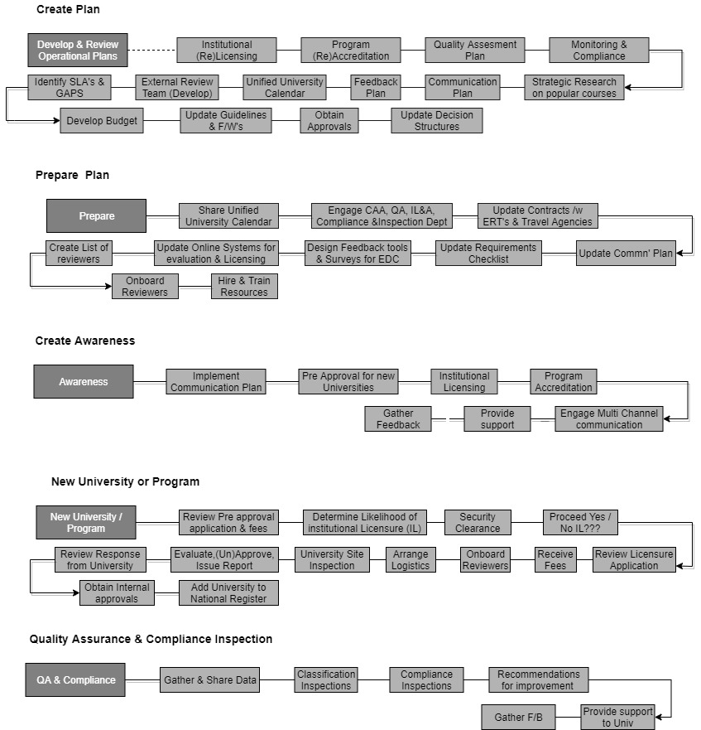**University Journey Workflow**

**Renew Licensure/Program Accreditation Workflow**

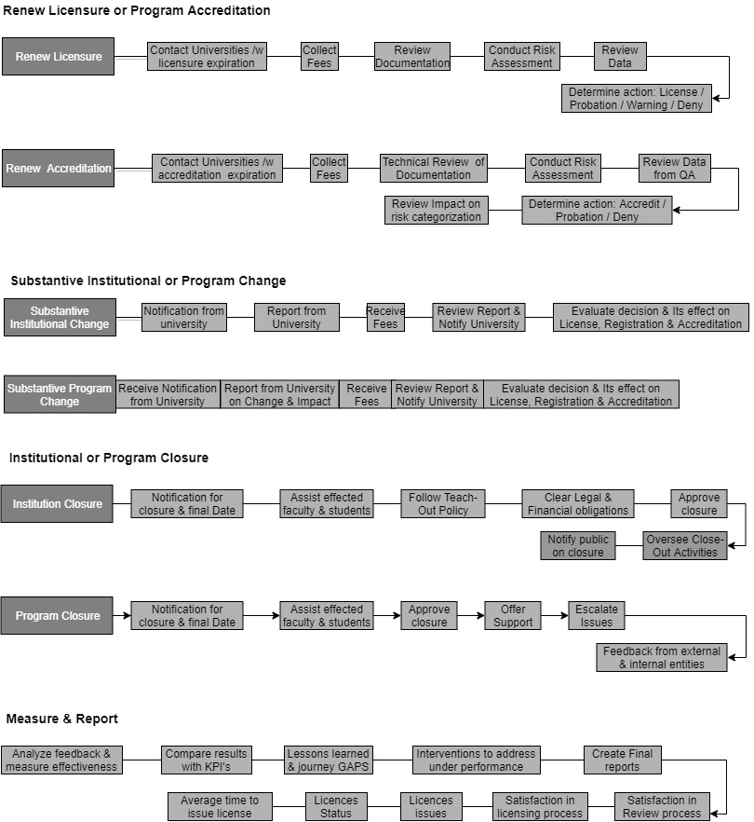

### **Education Service provider Journey**

* **Plan**

**Cascade Strategic Initiatives:**

* Cascade strategic initiatives and Higher Education strategy goals, and objectives to Institutional Licensing and Accreditation Department (IL&A) and any other MoEHEA department involved in the Education Services Provider Journey in order to incorporate them in the respective operational annual plans
* Education Services Provider Journey ownership and KPIs to respective departments and overall journey KPIs to the respective JO shall be developed and assigned

**Develop and Review Plans for Operations:**

* Education Services Provider Licensing and Re-licensing Plan, Education Services Provider Scoring System shall be developed or updated
* Education Services Provider Communication Plan including as a minimum: plan for Education Services Provider awareness, assessments and site visit calendar based on the re-licensing plan, Data Collection Plan from the Education Services Providers shall be developed or updated
* Feedback Plan to define feedback collection methodologies, timelines and targeted groups from customers and internal and external entities shall be developed or updated
* Define operational requirements, including resources, to be included in the Internal and External Entities Engagement Plan
* Internal and External Entities Engagement Plan shall be developed
* Find solutions to previous cycle gaps identified in the lessons learnt session
* Identify required SLAs

**Develop Budgets:**

* Annual costs based on – but not limited to – historical data, activities scheduled across the journey, and expected number of visits and related reviewers (if required) that will require services shall be determined

**Set and Review Standards and Decision Structures:**

* Frameworks, guidelines and standards (e.g. licensing standards, re-licensing standards), and processes for Education Services Providers shall be set or updated
* Decision structures and timelines related to the Education Services Provider Journey shall be updated if needed
* **Prepare**

**Engage with Internal and External Entities:**

* Engage with the following internal and external entities:
  + MoEHEA departments (IL&A Department and Equivalency Department)
  + MoE Shared Services through Shared Services Coordinators   
    External entities (FAHR and emirate-specific authority)
* Realign plans, if needed, based on relevant entities communications and confirm understanding of their respective roles

**Establish and Maintain Relationships with Internal and External Parties**

* SLAs, including the following as a minimum: Shared Services shall be developed or updated
* MoUs, including the following as a minimum: emirate-specific authority, FAHR shall be agreed or updated
* Other agreement with relevant stakeholders highlighted above as needed

**Design and Develop Content:**

* Content for the Education Services Provider Communication Plan (regarding licensing process) shall be designed or updated
* Application questions and requirements shall be designed or updated
* Interview questions shall be designed
* Requirements checklist for site visits shall be designed or updated
* Design feedback tools including Education Services Provider Feedback and Reviewer Feedback surveys and other surveys to be sent out by Education Data Center (EDC)

**Setup Resources Required:**

* Online systems based on standards for licensing, continuous monitoring, evaluation reports and updated content shall be setup or updated
* Onboard interviewers and inspectors based on set standards and review framework
* Hire and/or train resources and skills needed to deliver departmental plans, including as a minimum: Shared Services
* **Awareness**

**Engage Education Services Providers in Initial Phase:**

* Implement Education Services Provider Communication Plan including:
* Steps and list of criteria for achieving license (requirements)
* Steps and list of criteria for re-licensing
* Online application system
* License fees
* Timelines and visit schedule
* Distribute guidance material and FAQs
* Engage leadership from Education Services Providers or relevant representatives across different channels (via MoE website and meetings) with the goal of spreading awareness and information about the licensing process

**Provide Education Services Providers with Support:**

* Offer support to Education Services Providers (to be provided by the Happiness Center as per their respective training)
* Escalate and resolve issues to relevant departments where necessary

**Gather feedback**

* Gather feedback from Education Services Providers and internal and external entities to be used in monitoring, reporting and continuous improvement
* **Apply for/receive license**

**Manage Application Process:**

* Receive and manage Education Services Providers applications
* Manage tracking feature for applications to allow applicants to track status of their application throughout the process
* Receive application fees from applicants through a unified payment platform of the ministry

**Review Applications and Issue Preliminary Approval**

* Map received applications against pre-determined standards criteria
* Assess alignment to criteria
* Carry out interview to assess the capability and the eligibility of the Education Service Provider leadership
* Issue hiring permit for successful Education Services Provider leadership
* Conduct initial site visit
* Issue preliminary approval for successful Education Services Provider

**Perform Licensing Assessments and Site Visits:**

* Carry out background check in coordination with FAHR
* Issue equivalency of the Provider’s leadership’s degree
* Receive equated degree, commercial license, background checks and all other relevant permits and licenses required from other government entities for the operation of the Education Services Provider
* Coordinate second site visit schedule with the Education Services Provider
* Carry out second site visits and assess against criteria
* Develop score for the Education Services Provider and communicate accordingly

**Issue Licenses:**

* Receive licensing fee
* Issue licenses for Education Services Providers that receive a satisfactory score
* Communicate decision
* Consolidate database of licensed Education Services Providers, their course contents etc.
* Post list online to guide interested students to institutes licensed by MoE

**Provide Education Services Providers with Support:**

* Offer support to Education Services Providers (to be provided by the Happiness Center as per their respective training)
* Escalate and resolve issues to relevant departments where necessary

**Gather feedback**

* Gather feedback from Education Services Providers and internal and external entities to be used in monitoring, reporting and continuous improvement
* **Maintain licensing status**

**Gather Data from Education Service Providers**

* Request data records from Education Services Providers including as a minimum: student records, offered services/training courses including timelines and fees and employee/trainer records
* Update database of Education Service Providers

**Perform Inspections:**

* Carry out regular inspections on Education Services Providers regarding incompliance including inspection of data provided by providers.
* Issue fines for non-compliant Education Services Providers
* Issue warnings to non-compliant institutes if necessary

**Approve Advertisement Content:**

* Receive application for approval of advertisement content through online system
* Receive application fees
* Review advertisement content and ensure compliance to standards
* Issue approval for advertisement content

**Approve Changes in the Institution**

* Receive application for change in provider’s leadership through online system
* Receive fees for change application
* Carry out interview to assess the capability and the eligibility of provider’s leadership
* Issue equivalency of the new provider’s leadership’s degree if needed
* Issue approval for change in leadership if successful
* Receive application for other changes through online system in one of the following: Name of the Education Services Provider, Activities/scope of Education Services Provider application, Change of location, Change of fees
* Receive fees for change application
* Assess proposed change against standards and criteria
* Issue approval for activity/scope change

**Approve Training Courses and Certification (For training institutes/centers)**

* Receive notification from providers for the initiation of new training courses
* Ensure course offered is within provider’s scope
* Ensure selected trainers are suitable as per the standards
* Receive list of names of registered attendees
* Review and approve suggested fees for courses as per standards
* Review and approve content of certification to be issued by institutes where applicable)

**Revoke License**

* Assess triggers for revocation of license including but not limited to major incompliance highlighted in inspection, failure to renew license and court orders
* Recommend Education Services Provider license revocation and shut down
* Obtain necessary approvals of revocation and inform relevant authorities

**Provide Education Services Providers with Support:**

* Offer support to Education Services Providers (to be provided by the Happiness Center as per their respective training)
* Escalate and resolve issues to relevant departments where necessary

**Gather feedback**

* Gather feedback from Education Services Providers and internal and external entities to be used in monitoring, reporting and continuous improvement
* **Apply for License Renewal**

**Renew Licenses:**

* Follow-up with Education Services Providers whose licenses are about to expire and inform their representatives of steps for renewal based on re-licensing calendar
* Review application for license renewal and assess alignment to criteria
* Conduct site visits for license renewal and assess against criteria
* Issue fines if necessary
* Receive payment for relicensing and renew licenses accordingly

**Provide Education Services Providers with Support:**

* Offer support to Education Services Providers (to be provided by the Happiness Center as per their respective training)
* Escalate and resolve issues to relevant departments where necessary

**Gather feedback**

* Gather feedback from Education Services Providers and internal and external entities to be used in monitoring, reporting and continuous improvement
* **Transfer or Cancel License**

**Receive Application for License Transfer**

* Receive application from Education Services Provider to transfer license to a different owner
* Check for other institutional changes triggered by license transfer (change or leadership, scope, location) and assess accordingly
* Make decision about license transfer approval
* Inform emirate specific authorities of license transfer

**Receive Application for License Cancellation**

* Receive written request to cancel provider’s license from leadership
* Ensure that all pending obligations by the provider have been met including as a minimum: paying any pending trainers and staff salaries, completing other government entities’ requirements for provider closure, and managing student affairs
* Approve license cancellation
* Inform emirate specific authorities of license transfer

**Provide Education Services Providers with Support:**

* Offer support to Education Services Providers (to be provided by the Happiness Center as per their respective training)
* Escalate and resolve issues to relevant departments where necessary

**Gather feedback**

* Gather feedback from Education Services Providers and internal and external entities to be used in monitoring, reporting and continuous improvement
* **Measure and Report**

**Gather, Analyze, and Report on Data**

* Gather and analyze feedback, as a minimum, from Education Services Providers leadership and representatives, reviewers, customers receiving services, etc. regarding awareness plan, application process, license issuance, review process and overall effectiveness of licensing system
* Gather relevant statistics from the Education Service Provider Journey to inform policies and decision making
* Measure delivery of activities against the Education Services Provider Journey KPIs
* Prepare findings report and status updates

**Measure Performance and Ensure Continuous Improvement**

* Monitor results of the delivery of activities against department plans and KPIs/SLAs
* Conduct journey level and department level lessons learnt sessions with relevant MoEHEA Departments
* Identify gaps in the process/journey
* Put interventions in place to address underperformance and/or internal functional issues related to the Education Services Provider Journey

**Provide Final Reports**

* Prepare and provide reports relevant to the performance and outcomes of the Education Services Provider Journey to support leadership in decision making. This may include but is not limited to reporting on:
  + Journey related KPIs
  + Satisfaction rates among Education Services Providers with the overall licensing process
  + Satisfaction rates among reviewers with the overall Education Services Provider review process
  + Total number of licenses applied for by year
  + Status of licenses applied for (e.g. granted, revoked, etc.)
  + Average time taken to issue license
* Update and review planning and budgeting process to ensure continuous improvement is carried based on, customer satisfaction, performance measurement and lessons learnt

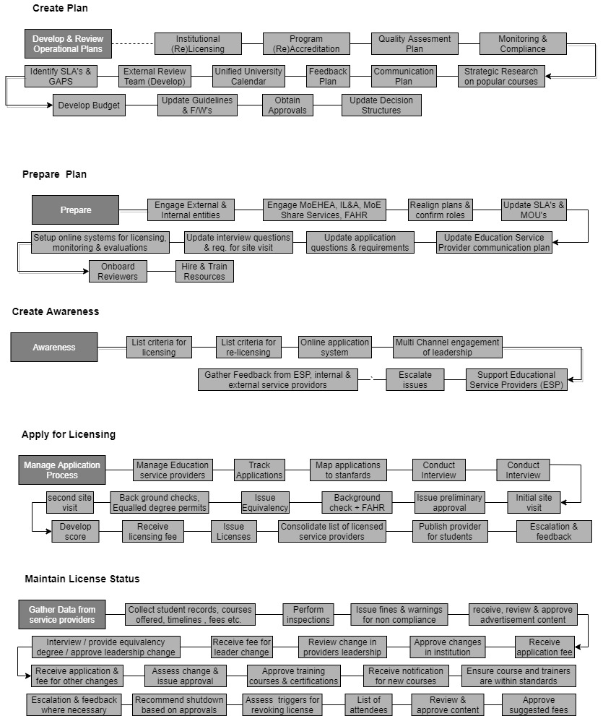**Education Service Provider Workflow**

**License Renewal/Transfer/Cancellation Workflow**

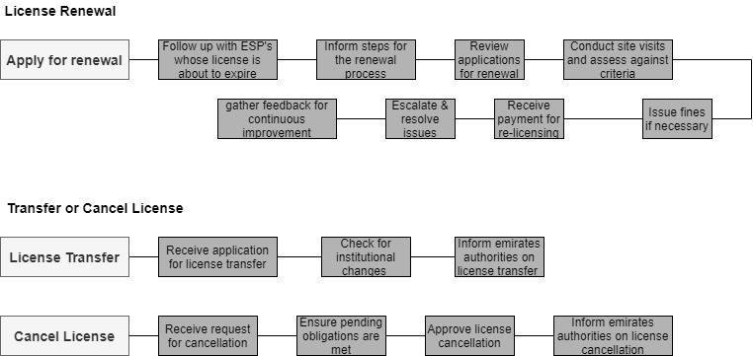

### **Education Professional Journey**

* **Plan**

**Cascade Strategic Initiatives:**

* Education Professional Journey Owner (JO) shall be assigned as per the set JO job description
* Cascade strategic initiatives and Higher Education strategy goals, and objectives to Professional Licensing Department and any other MoEHEA department involved in the Education Professional Journey in order to incorporate them in the respective operational annual plans
* Education Professional Journey KPIs based on Higher Education strategic priorities and previous cycle gaps to respective departments shall be developed and assigned

**Develop and Review Plans for Operations:**

* Solutions to previous cycle gaps identifies in the lessons learnt session
* Annual plans needed for the delivery of the Education Professional Journey shall be developed or updated which include:
  + Education Professional Licensing and Relicensing Plan, including content mapping for international licenses
  + Education Professional Communication Plan including unified calendar, outreach and marketing plan for Education Professionals’ awareness, Data Collection Plan
  + Exam Design Plan (MoE General Education)
  + Exam Logistics Plan including number of days needed, capacity, etc. (MoE General Education)
* Feedback Plan to define feedback collection methodologies, timelines and targeted groups from customers and internal and external entities shall be developed or updated
* Define operational requirements, including resources, shall be included in the Internal and External Entities Engagement Plan
* Education Professional Journey annual calendar with key milestones and timelines shall be developed or updated
* Required SLAs shall be identified

**Develop Budget:**

* Annual costs based on – but not limited to – historical data, activities scheduled across the journey, and expected number of Education Professionals that need to be licensed shall be determined

**Set and Review Standards and Decision Structures:**

* Frameworks, guidelines and standards (e.g. licensing standards, re-licensing standards, exam standards, international license conversion standards) and processes for education professional licensing shall be set or updated
* Update decision structures and timelines related to Education Professional Journey if needed
* **Prepare**

**Engage with Internal and External Entities:**

* Engage with the following internal and external entities:
  + MoEHEA (Professional Licensing Department and Institutional Licensing and Accreditation Department)
  + MoE General Education (EmSAT Department, Exam Logistics Team and School Operations Sector)
  + MoE Shared Services through Shared Services Coordinators
  + External Entities (universities, schools, exam centers, external regulators, National Qualifications Authority and training providers)

**Establish and Maintain Relationships with Internal and External Entities (e.g. SLAs/ MoUs/ Contracts):**

* SLAs, including the following as a minimum: MoE General Education and Shared Services shall be developed or updated
* MoUs, including the following as a minimum: schools, external regulators and National Qualifications Authority shall be developed or updated
* Contracts, including the following as a minimum: ECAE, exam centers and hotels shall be agreed or updated
* Other agreements with relevant stakeholders highlighted above as deemed necessary shall be developed or updated

**Design and Develop Content:**

* Education Professional Licensing and Relicensing Plan content (regarding licensing and re-licensing process) shall be designed or updated
* Exam preparation material and list of licensed training institutions shall be designed or updated
* Exam standards, exam questions and solution manuals shall be designed or updated
* All relevant Education Professional Journey guidance and awareness materials (brochures, website content, etc.) and align on content and messaging shall be designed or updated
* Education Professional Feedback Survey shall be designed or updated

**Setup Resources Required:**

* Unified portal, including the tracking feature, based on standards for licensing, continuous monitoring, evaluation reports and updated content (include clearance for School Leadership to review licensing status of Education Professionals) shall be setup or updated
* Hire resources and skills, as needed, to deliver the Education Professional Journey
* Conduct training for the following as a minimum: school outreach representatives
* **Awareness**

**Engage Education Professional in Initial Phase:**

* Implement Education Professional Communication Plan according to the unified calendar dates and spread awareness about:
* Steps for obtaining a license
* License and relicense fees
* Equivalency process
* Exam dates and timelines
* Number of retakes allowed and consequences of failing exams
* Training opportunities
* Engage Education Professionals across different channels (incl. website, social media, roadshows, through school leadership) with the goal of spreading awareness and information

**Provide Education Professional with Support:**

* Offer support to Education Professionals (to be provided by school outreach representatives and Happiness Center as per their respective training)
* Escalate and resolve issues to relevant departments where necessary

**Gather feedback**

* Gather feedback from education professional and internal and external entities to be used in monitoring, reporting and continuous improvement
* **Apply(Register**

**Manage Application Process:**

* Receive and manage applications
* Manage tracking feature for Education Professionals to track status of their application throughout the process

**Gather Information:**

* Collect Education Professionals’ data from applications
* Cross check information with that received from Education Data Center and external regulators
* Consolidate the information into a database

**Assess Applicant Profiles:**

* In cases where applicants have an international license, carry out license conversion
* Issue Provisional Teaching License (PTL) for eligible Education Professionals and communicate this with their respective school leadership

**Provide Education Professional with Support:**

* Offer support to Education Professionals (to be provided by school outreach representatives and Happiness Center as per their respective training)
* Escalate and resolve issues to relevant departments where necessary

**Gather feedback**

* Gather feedback from education professional and internal and external entities to be used in monitoring, reporting and continuous improvement
* **Apply(Train)**

**Support with Exam Preparation:**

* Review exam preparation material
* Post relevant exam preparation material on portal for Education Professionals’ perusal

**Inform Education Professional about Training Opportunities:**

* Post information about ECAE training
* Review list of licensed training institutions
* Post list of training institutes licensed by the Ministry to guide Education Professionals to potential external training options prior to taking their exam

**Provide Education Professional with Support:**

* Offer support to Education Professionals (to be provided by school outreach representatives and Happiness Center as per their respective training)
* Escalate and resolve issues to relevant departments where necessary

**Gather feedback**

* Gather feedback from education professional and internal and external entities to be used in monitoring, reporting and continuous improvement
* **Apply(Take Exam)**

**Schedule Exam Dates:**

* Prepare list of Education Professionals (retrieved from application step) that need to undertake the exam, as well as their exam date preferences
* Schedule exam dates and book exams centers, according to list of Education Professionals to be licensed, their preferences and available capacity
* Inform Education Professionals of scheduled dates

**On the Day Administration:**

* Allocate exam invigilators for on-the-day administration of the exams based on availability in the relevant departments involved

**Manage Exam and Generate Results:**

* Review exam design standards, questions and solution manuals
* Run and manage exam
* Generate exam results
* Assess fails and passes
* Communicate status and related next steps to applicants

**Provide Education Professional with Support:**

* Offer support to Education Professionals (to be provided by school outreach representatives and Happiness Center as per their respective training)
* Escalate and resolve issues to relevant departments where necessary

**Gather feedback**

* Gather feedback from education professional and internal and external entities to be used in monitoring, reporting and continuous improvement
* **Receive License**

**Issue Licenses:**

* Issue licenses for Education Professionals that receive a satisfactory score
* Consolidate database of licensed Education Professionals, number of times the exam was taken, etc.
* Communicate decision to relevant entities

**Renew Licenses:**

* Follow-up with Education Professionals on expired licenses and inform them of license renewal steps
* Receive payment for relicensing
* Assess e-portfolios of Education Professionals
* Renew licenses as per the guidelines
* Communicate with relevant entities list of Education Professionals with expired and renewed licenses

**Provide Education Professional with Support:**

* Offer support to Education Professionals (to be provided by school outreach representatives and Happiness Center as per their respective training)
* Escalate and resolve issues to relevant departments where necessary

**Gather feedback**

* Gather feedback from education professional and internal and external entities to be used in monitoring, reporting and continuous improvement
* **Measure and Report**

**Gather and Analyze Data:**

* Gather and analyze feedback, as a minimum, from Education Professionals, schools regarding Education Professional Communication Plan, Engagement Plan, application process, exam preparation material, exams, license issuance and overall effectiveness of licensing process in the education sector
* Gather and analyze relevant statistics from the Education Professional Journey to inform policies and decision making
* Prepare findings reports and status updates relevant to the Education Professional Journey

**Measure Performance:**

* Measure and monitor results of the delivery of activities against Education Professional Journey KPIs/SLAs through regular reviews
* Review results of the delivery of the Education Professional Journey

**Ensure Continuous Improvement:**

* Conduct lessons learnt sessions with relevant MoEHEA Departments
* Identify gaps in the Education Professional Journey
* Put interventions in place, including action points for next cycle, to address underperformance and/or internal functional issues related to the Education Professional Journey
* Mobilize additional resources where required
* Provide additional training and development activities where if required

**Report:**

* Prepare and provide reports relevant to the performance and outcomes of the Education Professional Journey to support leadership in decision making. This may include but is not limited to reporting on:
  + Journey related KPIs
  + Satisfaction rates of Education Professionals against key moments that matter (e.g. communication plan, etc.)
  + Number of Education Professional applications received (3 year trend minimum)
  + Percentage of incomplete applications out of the total application pool
  + Percentage of teachers licensed out of total teachers in UAE by Emirate and Sector
  + Number of teachers and other Education Professionals who applied vs. those who passed
  + Percentage of Education Professionals who passed from first exam trial
  + Average time taken to issue professional license

**Educational Professional Journey Workflow**

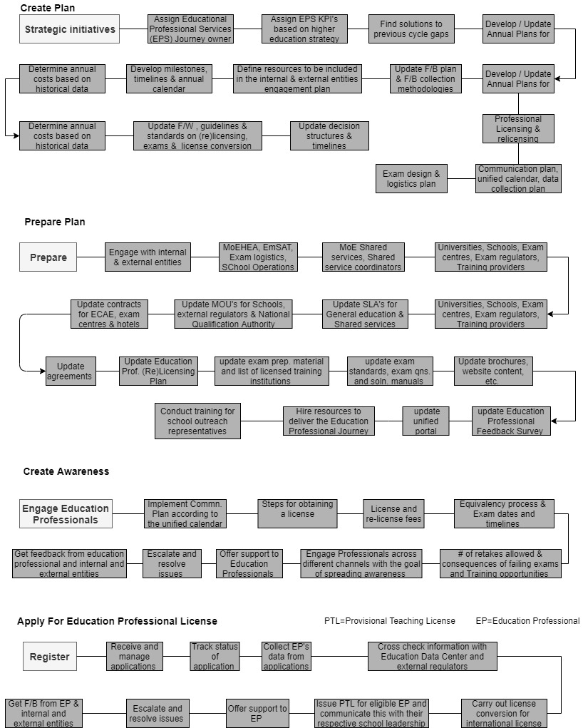

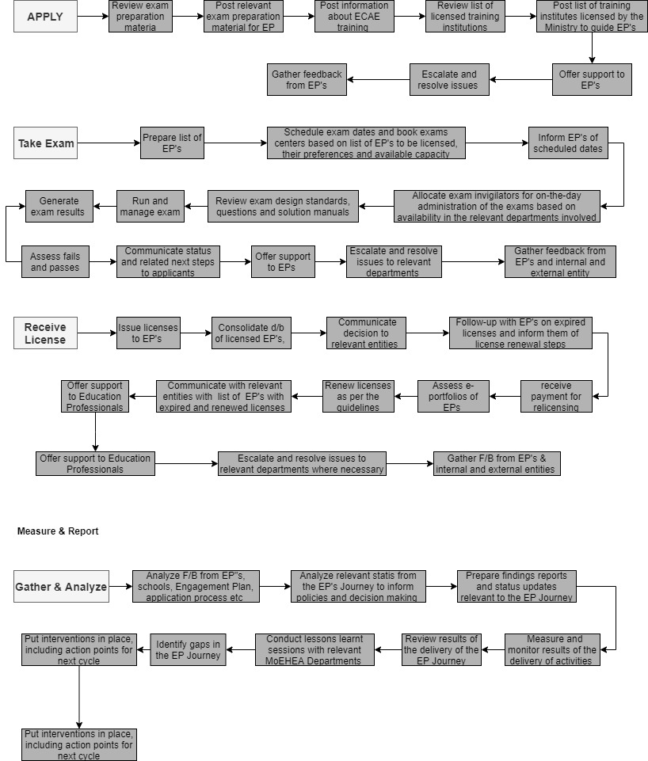

### **Workforce Employee Journey**

* **Plan**

**Cascade Strategic Initiatives:**

* Workforce Employee Journey Owner (JO)shall be assigned as per the set JO job description
* Cascade strategic initiatives and Higher Education strategy goals, and objectives to Equivalency Department and any other MoEHEA department involved in the Equivalency Journey in order to incorporate them in the respective operational annual plans
* Workforce Employee Journey ownership and KPIs to respective departments and overall journey KPIs to the respective JO shall be developed or assigned

**Develop Plans for Operations:**

* Solutions to any previous cycle gaps / issues identified in the lessons learnt session
* Annual plans needed for the delivery of the Workforce Employee Journey shall be developed or updated which include:
  + Higher Education Equivalency service plan, including the number of institutions to be included in Level 1 evaluation cases (e.g. Top 100, 200, 500)
  + Performance Management Plan (defines how KPIs will be measured and the frequency of measurement)
  + Communication Plan including student unified calendar, outreach and marketing plan for student awareness, and Data Collection Plan
  + Feedback Plan defining collection methodologies, timelines, and targeted groups of customers and internal and external entities
* Define operational requirements, including resources, to be included in the Internal and External Entities Engagement Plan and the approach to authentication (internal/external/hybrid – country-based approach)
* Required SLAs shall be identified

**Develop Budget:**

* Annual costs based on – but not limited to – historical data, activities scheduled across the journey, expected staffing required (informed by the percentage of applications where authentication may be outsourced), projected authentication costs (if conducted externally), expected number of applications (informed by appropriate data gathering and reporting on application trends) shall be determined

**Set Standards and Decision Structures:**

* Guidelines and standards (e.g. equivalency evaluation standards, service eligibility guidelines, application instructions, service definitions, complaint processing standards, application quality assurance standards, communication quality standards) shall be set or updated
* Update decision structures and timelines related to the Workforce Employee Journey if needed
* **Prepare**

**Engage with Internal and External Entities:**

* Engage with the following internal and external entities:
* MoE Shared Services (IT, Finance, HR, Call Centre, Customer Happiness Centers)
* External entities (Ministry of Foreign Affairs, embassies, external regulators, international higher education institutions, other recognition information centers)
* Realign plans based on relevant entities communication and confirm understanding of their respective role
* Communicate to relevant internal and external entities any new changes based on plans realignment (where necessary)

**Establish and Maintain Internal and External SLAs/MoUs/Contracts:**

* SLAs, including the following as a minimum: Shared Services shall be developed or updated
* Contracts, including the following as a minimum: authentication provider (if external authentication decided on) shall be agreed or updated
* Other agreements with relevant stakeholders highlighted above as deemed necessary shall be developed or updated

**Design and Develop Content:**

* Country profile development plan shall be designed or updated
* Update the Level 1 institutions list if needed
* All relevant Workforce Employee Journey guidance and awareness materials (website content, signposting sources etc.) and align on content and messaging shall be designed or updated
* Workforce Employee Feedback (Customer Satisfaction) Survey shall be designed or updated
* Workforce Employee Impact Survey shall be designed or updated

**Setup Resources Required:**

* Update website guidance on the service
* Online application portal based on standards for continuous monitoring and business planning (forecasting service volume and country of origin for incoming qualifications to inform recruitment, resource allocation, country profile development planning and potential external authentication implementation/extension) shall be setup or updated
* Training shall be conducted for the following (as a minimum): Equivalency Department Staff on new evaluation policies and service plan, and for Standards and Research Section, annual country profile development plan priorities;
* **Awareness**

**Engage Workforce Employee in Initial Phase:**

* Implement Workforce Employee Communication Plan (derived from the Equivalency Department Stakeholder Engagement Plan) and raise awareness about:
  + Steps for obtaining an equivalency statement
  + Eligibility and evaluation criteria
  + Fees and timelines
* Engage Workforce Employees across different channels (incl. website, social media) with the goal of spreading awareness and information on the Equivalency service

**Provide Workforce Employee with Support:**

* Offer support to Workforce Employee (to be provided by website, Call Centre (Level 1 queries) and the Equivalency Department Information Advisors as per their training and job description)
* Escalate and resolve issues to related departments where necessary

**Gather feedback:**

* Gather feedback from students and internal and external entities to be used in monitoring, reporting and continuous improvement
* **Apply(Submit Application)**

**Manage Application Process:**

* Receive full application through online portal
* Manage tracking feature, linking changes to application status updates to automated customer notifications. This includes but is not limited to confirmation of receipt and an initial application check (3-5 working days)

**Gather Information**

* Collect Workforce Employees’ data from applications to support agreed reporting requirements (e.g. country of application, country of qualification, purpose of application)

**Provide Workforce Employee with Support:**

* Offer support to Workforce Employee (to be provided by website, Call Centre and/or Customer Happiness Centers (Level 1 queries) and the Equivalency Department Information Advisors as per their training and job description)
* Escalate and resolve issues to related departments where necessary

**Gather feedback:**

* Gather feedback from students and internal and external entities to be used in monitoring, reporting and continuous improvement
* **Apply(Undergo Evaluation)**

**Manage evaluation and authentication process:**

* Provide an evaluation of the application in line with evaluation policy
* Apply for qualification authentication on behalf of applicant
* Monitor authentication turn-around times
* Ensure authentication outcome clearly logged
* Communicate negative outcomes with relevant stakeholders
* Complete equivalency statement for cases where pre-existing data is found or cases approved by Standards and Research Group

**Provide Workforce Employee with Support:**

* Offer support to Workforce Employee (to be provided by website/portal updates and the Equivalency Department Information Advisors as per their training)
* Escalate and resolve issues to related departments where necessary

**Gather feedback:**

* Gather feedback from students and internal and external entities to be used in monitoring, reporting and continuous improvement
* Receive Equivalency Statement

**Issue equivalency statements:**

* Issue equivalency statements for applications which successfully completed the evaluation process
* Inform customer of next-steps and complaints procedure
* Issue customer satisfaction survey

**Provide Workforce Employee with Support:**

* Offer support to Workforce Employee (to be provided by website/portal updates and the Equivalency Department Information Advisors as per their training)
* Escalate and resolve issues to related departments or Quality Standards Committee where necessary

**Gather feedback:**

* Gather feedback from students and internal and external entities to be used in monitoring, reporting and continuous improvement
* **Measure & Report**

**Gather and Analyze Data:**

* Gather and analyses feedback, as a minimum, from Workforce Employees who have received a complete equivalency statement; Customers who were not able to obtain an equivalency statement; and from stakeholders receiving equivalency statements from workforce employees to determine relevance of statement information for their purposes
* Gather relevant statistics from the Workforce Employee Journey to inform policies and decision making
* Prepare findings reports and status updates relevant to the Student Journey

**Measure Performance:**

* Measure and monitor results of the delivery of activities against Workforce Employee Journey KPIs according to the agreed Performance Management Plan (measuring both service turnaround times and quality)
* Measure delivery of research activities against departmental targets
* Review results of the delivery of the Workforce Employee Journey

**Ensure Continuous Improvement:**

* Conduct lessons learnt sessions with relevant MoEHEA Departments
* Identify gaps in the Workforce Employee journey, in particular the impact of the evaluation policy and customer satisfaction and impact survey feedback
* Put interventions in place, including action points for next cycle, to address underperformance and/or internal functional issues related to the Workforce Employee Journey
* Mobilize additional resources where required
* Provide additional training and development activities where if required

**Report:**

* Prepare and provide reports relevant to the performance and outcomes of Workforce Employee Journey to support leadership in decision making. This may include but is not limited to reporting on:
* Journey-related KPIs (including but not limited to percentage of applications submitted that are eligible for the relevant service; timeframe for checking of incoming applications, error rate in declined applications, error rate in completed applications)
* Satisfaction rates of workforce employees against key moments that matter (e.g. ease of application, clarity of information (pre-application and throughout the application process), clarity and level of stakeholder acceptance of the equivalency statement
* Volume and breakdown of equivalency applications under the workforce employee journey including but not limited to the number of applications received, qualification country of origin to inform a country league, field of study, risk level (number and percentage of applications at Level 1/2/3), average and median timeframe for authentication – overall and by country, number of positive/negative authentication outcomes with any discernible trends identified and analyzed
* Number of complaints (closed/pending and resolved (Level 1 vs escalated)

**Workforce Employee Workflow**

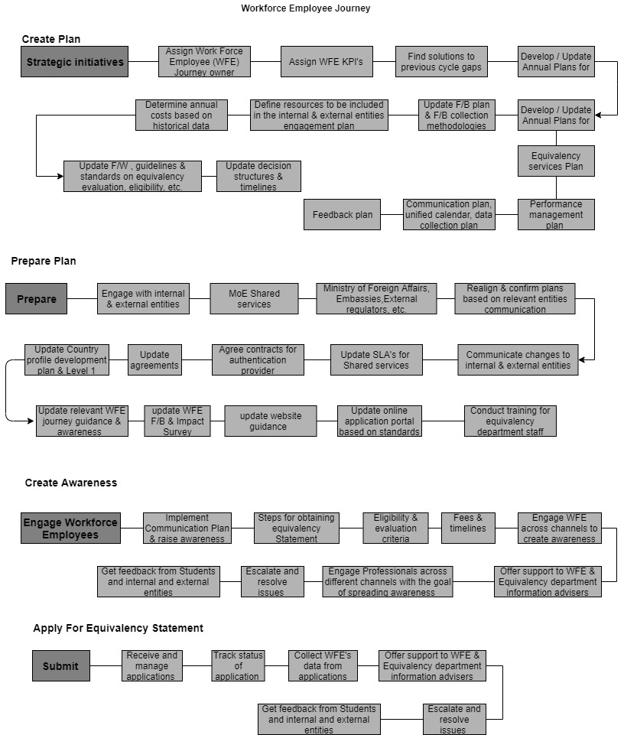

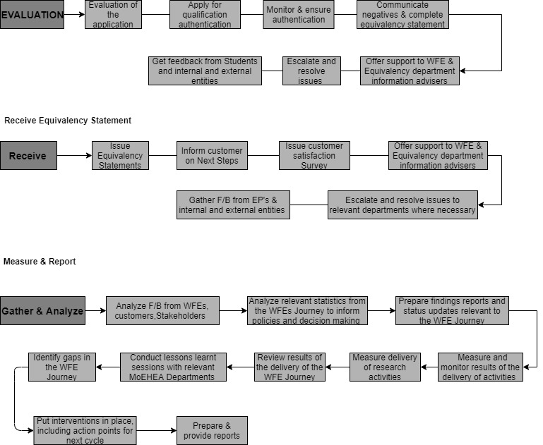

### **Shared Services Management Process**

* **Plan**

**Set Up for Shared Services Management:**

* Assign Shared Services Coordinators (SSCs) as per the job description
* Review and enhance Terms of Reference for the Shared Services Committee composed of departmental and functional executives
* Develop Shared Services Coordinators goals and operational KPIs

**Develop and Review Plans for Operations:**

* All plans for the management of end-to-end Shared Services process (including the Data Collection Plan) shall be developed or updated
* Roles and responsibilities shall be developed or updated for the following as a minimum: Shared Services Coordinators, MoEHEA departments, Journey Owners and Shared Services department
* Definitions for RAID (Risk, Assumptions, Issues, Dependencies) log shall be developed or updated
* Dispute resolution and escalation mechanism shall be developed or updated
* Appropriate decision making structures to ensure consistency in decision making timelines shall be designed or updated
* Stakeholder Communication Plan (to communicate changes in system, SLAs, KPIs, etc.) shall be developed or updated
* Identify resources required
* Find solutions to previous cycle gaps identified in the lessons learnt session
* **Prepare**

**Engage with Internal Entities:**

* Communicate the new shared services end-to-end processes by engaging with:
* MoEHEA departments
* MoE Shared Services

**Gather Requirements and Identify Required SLAs:**

* Gather requirements from MoEHEA departments for shared services
* Identify required SLAs

**Develop/Update SLAs:**

* Define Scope of Service:
* Agree with relevant MoEHEA and Shared Services departments on the scope of services to be provided
* Define Service Levels, related KPIs and Targets:
* Benchmark the service performance metrics against similar, competitive organizations or against outside vendors
* Review historical data on reasonable threshold on target set
* Map out the entire service level process
* Define the service levels to be measured
* Determine the way in which the service level will be measured
* Discuss target to be achieved in the service level between relevant stakeholders
* Assign user and provider responsibilities
* Finalize SLA Documents and Obtain Approvals
* Develop SLAs between MoEHEA departments (Finance Administration, Contracts and Procurement Administration, IT Administration, Personnel Affairs, Recruitment, Training and Professional Development, Education Data Centre, Happiness Centre
* Receive approval from Shared Services Committee on services scope and set targets
* Provide support to MoEHEA departments wanting to develop SLAs with individual MoE departments beyond shared services (e.g. SLA between Professional Licensing Department and EmSAT) if required

**Communicate Final SLAs to Relevant Departments:**

* Communicate agreed SLAs to all relevant MoEHEA and Shared Services department

**Setup Resources Required:**

* Setup and/or update technology & systems requirements to deliver the Shared Services Management Process (e.g. dashboards to manage KPIs)
* Hire and/or train resources and skills needed to deliver the Shared Services Management Process
* **Deliver**

**Implement Shared Services Management Process and Relevant Plans:**

* Mobilize key resources from Shared Services Coordinators, MoEHEA departments, Journey Owners and Shared Services departments
* Implement the Shared Services Management Process according to the SLAs
* Maintain relationships with relevant departments throughout the journey

**Escalate Issues:**

* Manage and adhere to the escalation procedure
* Highlight incompliance or underperformance in SLAs
* **Review**

**Gather, Analyze, and Report on Data:**

* Gather and analyze feedback from, as a minimum from, Shared Services Coordinators, Shared Services Committee, MoEHEA departments, and Shared Services departments
* Gather and analyze relevant statistics from the Shared Services Management Process to inform policies and decision making
* Manage operational master data and RAID log

**Measure Performance and Ensure Continuous Improvement:**

* Measure service-level performance against agreed KPIs
* Conduct lessons learnt sessions with Shared Services Coordinators, MoEHEA departments, and Shared Services departments
* Identify gaps in the process/journey
* Put interventions in place to address underperformance and/or internal functional issues related to the Shared Services Management Process
* Disseminate updates and reports to relevant MoEHEA departments and Shared Services departments
* Exchange insights with Shared Services Coordinators to improve processes
* Discuss and agree on next steps regarding conflict resolution, incompliance, or underperformance incidents
* Update and review planning process to ensure continuous improvement is carried out
* Adjust, revise and/or terminate SLAs:
* Communicate the rationale for termination to all relevant departments
* Communicate the reviewed/updated Service Level to all relevant departments
* Provide direction around future opportunities and next steps

**Provide Final Reports**

* Prepare and provide reports relevant to the performance and outcomes of the Shared Services Management Process to support leadership in decision making. This may include but is not limited to reporting on:
* SLA Adherence Report
* Shared Services Performance reports, including Underperformance or incompliance
* RAID Log

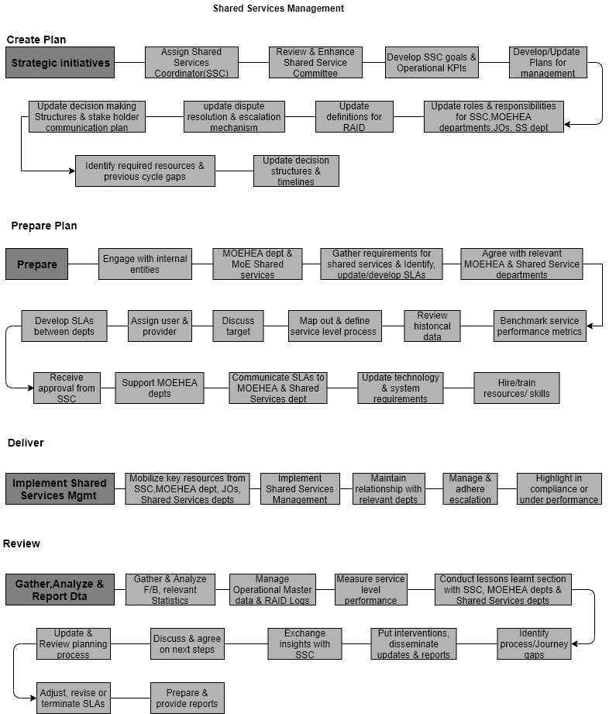**Shared Services Management Workflow**

|  |  |
| --- | --- |
| **Requirements** | **Details** |
| User Experience and  UI Design | * The application will be developed only in English & Arabic * The layout and graphical components will be created considering the usability factors |
| Performance | * Application will allow users to have smooth and quick access to the information or services they require. |
| Security | * Web security standards will be followed. |

## NON-FUNCTIONAL REQUIREMENT (OTHERS)

## System Architecture

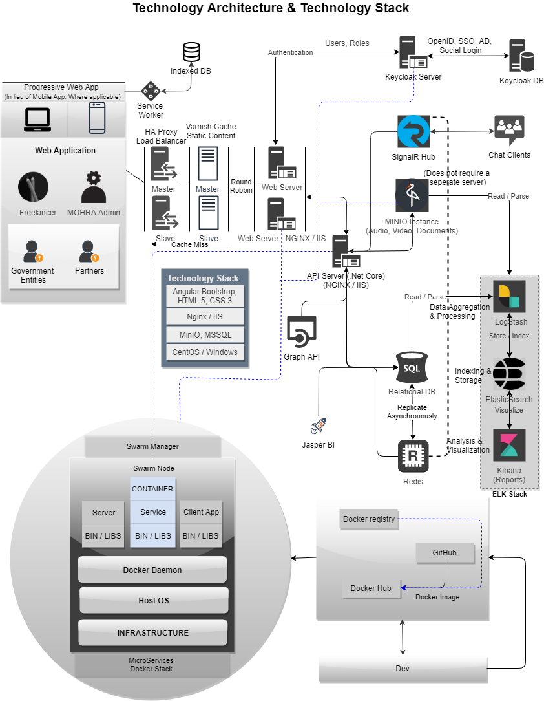

## Server Topology

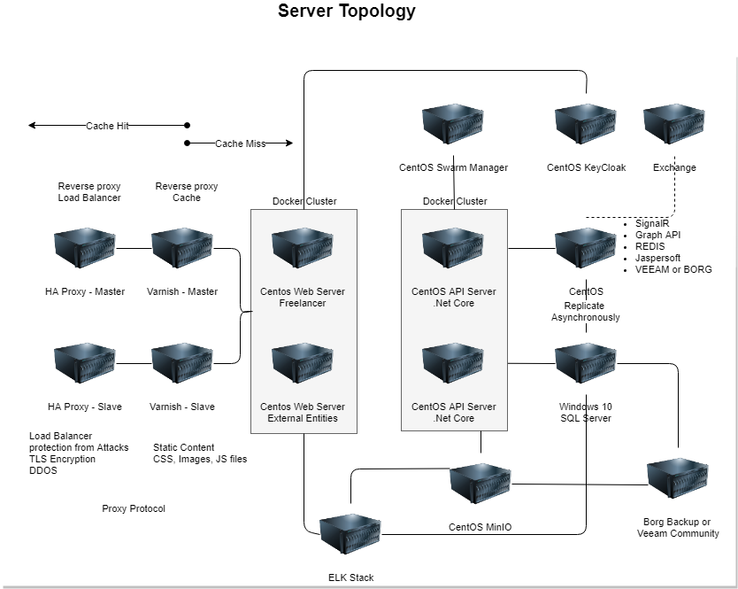

## Security

## Quality Analysis Cycle

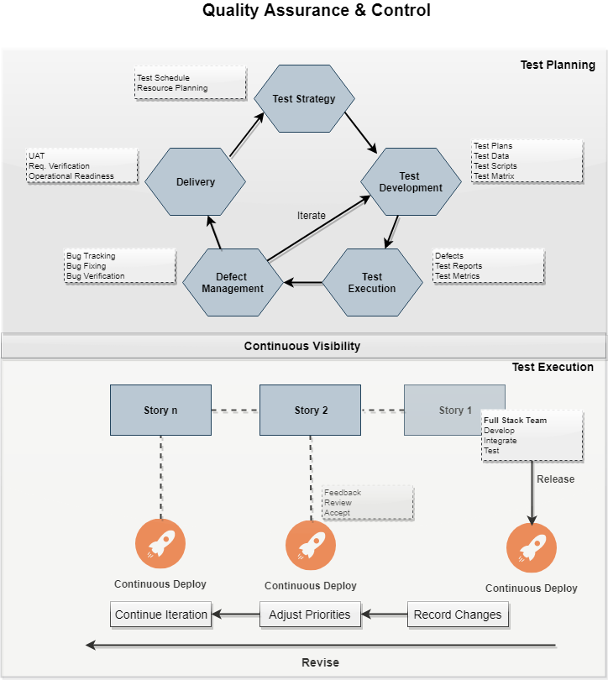

## Release and Deployment

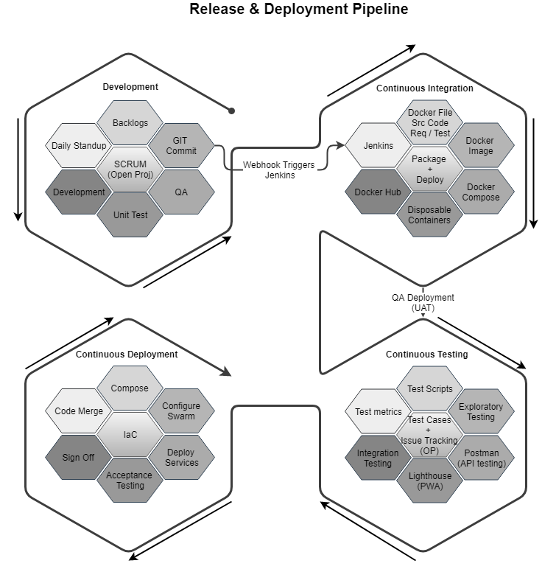

## PROPOSED SYSTEM ENVIRONMENT



.Net Core, MVC

Angular

HTML5 / CSS3

Java Script

Windows

IIS

MS SQL

**MS SQL2012  
Windows 8/10  
Web Services**

## TECHNICAL CONFIGURATIONS

### **DEVELOPMENT TOOLS**

* ASP.Net 4.5 / >net Core
* MS SQL
* HTML5 / CSS 3
* Angular
* Web services, Ajax, JavaScript

### **RECOMMENDED WEB HOSTING PACKAGE- DEDICATED HOSTING**

* Operating System : Windows Server
* CPU : 4 core
* Domains: Unlimited
* Disk Space: 200 GB
* Monthly Bandwidth: 50 GB
* Web site Server Software – IIS 7.5 +
* ASP.NET 4.5

### **BROWSER**

* Chrome version: 56
* Firefox version: 51
* Internet Explorer:11
* Safari:13

### **HARDWARE**

The application is reliant on hardware interfaces to provide a seamless automated user experience.

* Computer with Windows 8 or 10 OS
* Compatible Browsers as specified in section 6.2.3

### **TECHNICAL STANDARDS**

* Screen Resolutions

1080 x 1920, 720 x 1280, 750 x 1334, 640 x 1136

* Testing Devices
  + Android
    - Moto G( Marshmallow)
    - Alcatel (nougat)
    - Google Pixel (pie)
  + iOS
    - iPhone 5S and above
  + OS Version
    - KitKat and above
    - iOS 9.0+

### **TECHNICAL GUIDELINES**

The guidelines provide instructions and conditions that will be adhered to during the development of the mobile application.

* API will be used, as the case may be, in realizing the features and functionalities mentioned
* The client will finalize the functional requirements and UI/UX before the commencement of any development activities
* Verbat will be testing the app in the mentioned devices only. Testing on devices other than the ones mentioned under the “Technical Standards “ will have to be specified and provided by the client at the beginning of the development phase
* The client will have to provide the details of the testing devices they are using before the start of development phase.
* Client should provide the relevant Developer's Account credentials before the development phase. In case Verbat needs to create the developer id additional charges will be incurred by the client
* The apps will be developed / created within the guidelines of Android and IOS. Verbat will strictly follow the guidelines provided by the respective store. Verbat will inform the client if any of the client requirements/ request deviates from it.
* Customization of the features of the app will be susceptible to the limitation imposed by the respective platform/ store.
* OS version support will be limited to the ones mentioned under ‘Technical Configuration’, further support will have to go through change management.

## PROJECT DELIVERY

### **PROJECT MANAGEMENT**

The Verbat development center strictly follows industry standards on quality. The project management is process governed by the Verbat Quality Management system and is put to verification through internal audit programs that happen from time to time. Verbat will dedicate a project manager for the proposed implementation. Verbat proposes Client to identify one project manager who will be driving activities to be undertaken by Client to be the single point of contact for Verbat.

### **ROLES & RESPONSIBILITIES**

Verbat will assign a dedicated Project Manager/Project Lead to lead the project, who will be the first point contact for Client. He/she will be responsible for planning and managing the various activities within the project. He/she will work closely with Client Project Manager, to give periodic status updates and ensure high level of visibility and comfort on the progress of the project. The Project Manager/Project Lead will lead the co-ordination between Verbat and Client, thus enabling smooth transitioning of Client requirements to the Verbat ’ offshore delivery team, and provide visibility as well as comfort on the progress of the services to Client.

He/she will have periodic meetings with Verbat ’ s Senior Management, thus ensuring Verbat ’ Management commitment and focus on Client initiatives.

### **PROJECT IMPLEMENTATION PLAN**

Verbat will be providing the solution in a stand-alone fixed bid approach which ensures minimum viable solution for quick wins with core focus on the long-term business objective and outcome. Once the implementation is over, Verbat will initiate the application maintenance process (once the maintenance contract is signed) which continues to extend after the implementation.

### **DELIVERABLES**

* Project Plan
* Software Requirement Specification Document (SRS)
* UI/UX Design
* Functional Specification
* Quality Analysis plan
* Testing plan and deliverables (testing scenarios and scripts)
* Data migration plan
* Setup documentation
* Source Code
* Fully Developed & Tested Application
* Implementation and switchover plan
* Post implementation plan

### **DELIVERY ACTIVITY SUMMARY**

|  |  |
| --- | --- |
| Activities | Description |
| Detailed requirement Analysis | Verbat team to conduct detailed study of requirement for the phase. If clarification is required, team will reach out to Client for more information and/or time for discussions. |
| DB Design | DB design for central and test DB. |
| Software Requirement Specification document (SRS) | Once the requirement analysis is completed, Verbat team will submit the SRS document for approval |
| UI/UX Design, Prototyping | Based on the SRS, Verbat UX/UI team will work on the UI/UX of the screens and submit for approval |
| Functional Specification Document (FS) | Once the UI/UX is approved, Verbat shall submit an FS document for approval. |
| Development | Actual system development starts based on the FS. This involves detailed design and software development of Web Application. |
| Testing | Test Planning, test plan creations, internal, integration testing and user acceptance testing. |
| Deployment | Deploying the latest built in the Verbat Test Server. |

### **ESTIMATED DELIVERY TIME**

The effort estimated for delivering the application will be as below:

* 00 UAE working days for the UI/UX from the date of approval of the SRS
* 00 UAE working days for the development of the application from the Date of Approval of the FS.

| **Activity** |
| --- |
| Contract Signoff (T0) |
| Project Initiation & Initiating requirement gathering |
| Software Requirement Specification Document(SRS) |
| SRS Approval (T1) |
| System UI/UX-Complete |
| System UI/UX-Approval (T2) |
| Functional Specification (FS) |
| FS Approval (T3) |
| Development Phase-Complete |
| Perform QC (Unit Testing and Integration Testing) |
| System ready for UAT |
| UAT Acceptance on Verbat server (T4) |

* The above-mentioned timeline is in UAE Working Days
* The initiation of the UI/UX development is dependent on the confirmation of SRS. SRS will be submitted post the confirmation of the project along with LPO, signed proposal and advance payment
* The above mentioned timeline for development is post the confirmation of FS
* Documentation submitted after project initiation and system study supersedes any proposal or documentation submitted during initial requirement gathering / discussion / negotiation
* Project plan will be submitted post the confirmation of project with necessary payments
* Any delay in getting the approvals of deliverables from client will cause change in timelines and the revised timelines will be updated in weekly status reports shared with client after the project commencement
* All approvals and queries regarding the client requirement and any queries which may hinder the project advancement at any stage should be answered by the client within 24 hours from the time of initiation, failing which the time delay will get added to the actual effort and timeline which was estimated.
* On project confirmation, Verbat requires a lead time of minimum seven (07) days for resource mobilization.

### **DEPLOYMENT DETAILS (AT CLIENT’S BEHEST)**

* Client can opt for hosting the application at Verbat’ Server.
* If deployment is at the client’s server, responsibility of deploying the application onto the production environment after conducting the necessary acceptance testing will lie with the client unless and until Verbat ’ support is contracted for deployment.

### **RELEASE PLANNING**

* Client will be informed about the release date and time through email.
* Client performs the UAT

### **RISK CONTINGENCY PLANNING**

Verbat has identified various risk factors associated with this assignment and understands the impact of these risk factors on the project schedules. The objective of this section is to highlight for both Verbat and client, the risk factors, to analyze the impact of the risks on project execution, and to propose strategies to control and reduce the impact of the risk factor. These various risks, which could arise during the project, are tabulated below along with mitigation implementation.

| Type of risk | Impact | Risk Mitigation | Risk Handling |
| --- | --- | --- | --- |
| Scope Creep | H | Functions and features will be detailed in system requirement documents and will go through client approval. Once this document is approved, any change to requirement will go through change management review for possible impact assessment. | Proper change management procedure will be implemented. |
| Delay in customer feedback | H | The plan is prepared with enough lead-time for customer reviews and approvals.  The customer is indicated with the dates when the document is expected after review and approval. | The request for feedback will be escalated if not attended at the right time so that the schedules are not affected. Deemed acceptance criterion is set up front and will be followed. |
| Non-availability of necessary software’s, frameworks, database instances and infrastructure at client’s hosting environment(If hosting support is provided by Verbat ) | M | Client will be informed in advance on these requirements. | Possible impact to schedule. |
| Manpower attrition | L | All efforts would be made to ensure process dependence rather than being person dependent. As a risk mitigation plan Verbat will train backups. | A new person will be identified as early as possible, provided the required project-specific training and mentored by the senior members of the team to minimise impact of attrition on the project. |

*H-High, M-Medium, L-Low, NA-Not Applicable*

## PROJECT ASSUMPTIONS

The project solution and technology is created from the initial understanding of the requirement shared with Verbat through mails and meetings. The proposed solution is based on the following assumptions:

### **OBJECTIVE**

* The requirement is to develop an Integrated Higher Education Platform with the functionalities as defined in ‘Functional Requirements’ section

### **DESIGN**

* Client to provide Verbat with the branding guidelines.
* Color theme shall be provided by the client
* Client shall provide licensed images and logos in specified size & format
* Client shall provide the text and associated images for the proposed application. Text should be provided in digital format preferably in MS Word 2013 or above
* Verbat may use template based design for the application

### **DEVELOPMENT**

* The proposed application front end and backend would be developed in English & Arabic
* Development Contingent upon timely feedback from client
* The client will finalize the functional requirements and UI/UX before the commencement of the development of the project
* Client shall approve the UI/UX for the web application before development work starts
* Final data needs to be entered by the client via the application
* Client will provide sample data to test the application
* Testing of web application will be done in latest versions of Google Chrome, Mozilla, Edge web browsers only
* Client will procure templates, SSL certificates (if applicable)
* Client will host and manage the application on infrastructure (server / cloud) recommended by Verbat for managing database and application backup inclusive of images
* Application and data backups are subject to the purchase of such services at an extra cost
* Internet connectivity is required for the functioning of the Web portal
* Does not support offline access or operations

# **OUT OF SCOPE**

With the ever evolving digital market, the requirement should be clear to both the parties involved, hence the importance of mentioning the out of scope details of the project. Following are considered to be out of scope while creating this proposal:

* Purchase of images, fonts
* Any language other than English & Arabic
* Migration of existing data / Database migration
* Content writing / proof reading / Data Replication / Manual data entry
* Content or image procurement or uploading or editing
* Audit Trail
* End user testing and load testing
* Developer account creation and Maintenance (Play Store)
* Adding new features to the application other than mentioned in the functional specifications. Such requests will be handled via change management. *For Change management details, please refer section titled “Change Management” in the*
* Annual Maintenance Contract (Bug fixing, debugging, enhancements) – Please refer section titled “Maintenance and Support”, unless contracted for.(refer to section 4.2)
* Hosting Infrastructure and Maintenance (web and email hosting), unless contracted for.
* Application Deployment on the server and respective stores, unless contracted for.
* Backup solution and Disaster recovery unless contracted for.
* Physical deployment onsite / installation of the application in devices and Physical connection, installation of system.
* Integration with third-party, if any, other than mentioned in the functional specifications
* Hardware Integrations / procurement and purchase
* Procurement of SMS gateway / payment gateway / email gateway
* SSL Purchase and installation, if any
* Plugin/template purchases, if any
* OS other than mentioned in the Hardware Interface
* Relevant / related software libraries

## CHANGE MANAGEMENT

Any addition which comes out of the project scope, upon and after the launch of the application will be considered as change management. Verbat recommends the following change management procedure for the same.

* Any change which comes out of the project scope, which was discussed, documented, and mutually approved by both the parties in the requirement stage, will be carried out only through raising a change request.
* Change request will be studied and an impact analysis on the existing work flow will be performed.
* On finalizing the impact, effort estimation for the change will be calculated and raised as additional requirement.
* Verbat will initiate the change request only after getting a formal approval from the client for the additional changes raised.
* Any change from the scope will be charged at AED 1,200.00 per man day effort and approval from the clients will be availed before commencing on any change management.

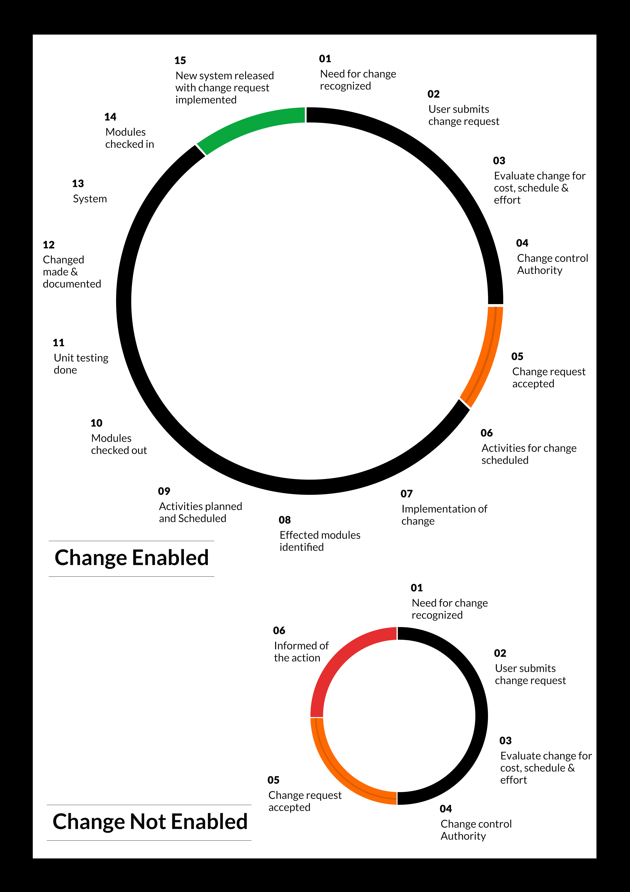

## MAINTENANCE & SUPPORT

* Maintenance contracts by default are supported as per the basic SLA terms.
* AMC with Basic SLA is charged at 25 % of the total project value. Additional Effort/change management request will be added towards Total Value of the Project to determine the AMC value.
* Maintenance support is limited to providing application support for ensuring the consistency of the look-and-feel, bug fixes and user issues i.e. maintenance and support of the existing features of the application.
* Support does not in any way cover providing technical or other support to the end users. The maintenance agreement does not include functionality changes or feature additions which are handled as change requests which will be charged AED 1,200.00 per man day. AMC does not include server support, maintenance and application deployment.
* AMC charges will cover Off-Site Support and Debugging. Support includes E-mail, Telephone and Chat unless explicitly specified. In the event, the application is hosted with the client; necessary remote desktop connectivity should beprovided for carrying out maintenance activity.
* Gap in AMC - In case if the client does not opt an AMC for a year and want to renew it after that period, 50% of the AMC amount for the year for which AMC is not taken will also be payable if the client wishes to renew the AMC contract.

*Note:*

* *Please note that the AMC support shall start only after all the necessary sign-offs (AMC Document) to this effect have been given.*
* *It is not mandatory that the client should opt for an AMC (replace with perhaps: It is mandatory that the client opts for an AMC). The client will still be supported on an ad-hoc basis on an agreed man-day rate.*
* *AMC Payment Terms: 100% to be paid as advance.*

## SERVICE LEVEL AGREEMENT (SLA)

|  |  |  |  |  |
| --- | --- | --- | --- | --- |
| **SLA Type** | **Max Response Time** | | **Max Resolution Time** | **Target** |
| Basic | 1  working day | 3 working days | | Request / incident / problem tickets |
| Advanced | 5 Business Hours | 12 Business Hours | | Request / incident / problem tickets |
| Priority | 3 Business Hours | 5 Business Hours | | Request / incident / problem tickets |

*Note:*

* *We provide Basic SLA as standard with AMC while Advanced and Priority SLAs attract additional charges.*
* *Time zone applicable (8:00 am to 5.00 pm, Sunday to Thursday)*

AMC Option:

Client can opt for time and material based Annual Maintenance, the details of which will be shared post the completion of project.

# **TERMS & CONDITIONS**

## ACCEPTANCE CRITERIA

* UAT (User Acceptance Test) sign off should happen within 07 Days from the first release of the application and the acceptance confirmation needs to be mailed to Verbat failing which Verbat will consider the project as approved by the client.
* Any comments or reason for rejection need to be documented and the same needs to be sent as an email from the official mail id of client to Verbat on or before 07 days from the first release.
* Timeframe for acceptance for any further release will be mutually agreed and finalized between client and Verbat depending on the UAT Comments

## WARRANTY

* Verbat shall provide a bug ﬁx warranty at no additional cost for 30 days from the date of acceptance of the project, for correction of any errors in the developed application that may be attributed to Verbat.
* However, this does not cover modifications by Client, or use of the application on an environment other than the proposed environment, or other circumstances outside Verbat’s reasonable control. In such a case Verbat reserves the right to charge for its services.
* All error corrections will be executed at Verbat India office. In the event of any need for on-site work, all expenses incurred for such trips will be payable to Verbat by Client.

## SOURCE CODE & INTELLECTUAL PROPERTY RIGHTS

* Upon completion of the Project and 100% completion of the payment, client will have access to the source code except for propriety codes, developer tools and third party applications etc.
* The solution offered will be the intellectual property of the client and will be made available to the client on an “unlimited license” basis.
* Modifications by third party/person: No person or organization, other than Verbat or any person authorized by Verbat in writing, has any permission to modify/change the software Solution to be eligible to get continued support from Verbat as per the support terms defined under this document.
* Liabilities/Damages: Verbat accepts no liability or damages of any kind arising out of use or non-use of the software delivered. The responsibility of testing of software lies with Client.

## GENERAL TERMS AND CONDITIONS

* Offer Valid for 30 calendar days from the date of submission of the Proposal.
* An average of 20 working days are assumed in a month.
* All the projects activities will be carried out from our off-shore development center in India
* All the documentation will be provided in English.
* Third party components may be used to develop this application.
* The scope of the project is to develop the Application as detailed in the scope of the project and mentioned in this proposal. Any changes or additions will have to go through change management.
* This proposal would have been derived or concluded from either the RFQ /RFP/data shared via email / information transferred during an initial requirement analysis meeting / tele-conversation. Verbat reserves the right to change the terms of this proposal as the final terms (including the costing), features & functionalities and timeline could change during the course of the project. Hence any fees quoted / timeline committed in this proposal may not be considered as final unless agreed and signed by both parties.
* Web Application will be best viewed only in the environment mentioned in the section Browser Compatibility
* All Source Codes and other project artefacts would adhere to the Verbat document templates and internal coding standards.
* The documents delivered to the client includes the ones mentioned under ‘Deliverables’ and these will adhere to Verbat’s internal document standards.
* Acceptance criteria shall be based on the clauses which were mutually discussed between Verbat and client at the Requirement Analysis phase and the same will be documented and approved by both parties through official emails
* In case Client requires any extension of the proposed acceptance schedule, the associated effort and cost of such extension can be mutually reviewed.
* For any circumstances if project needs to be put on Hold / Stop it requires minimum request notice period of 1 week along with duration for which request will be addressed by management and final decision on the request will be based on that
* If deployment is done in client’s server, Verbat cannot be held responsible for any performance issues arising due to hardware malfunctions.
* Client is responsible for data backup in case the application is not hosted on Verbat server.
* Source code will only be delivered or uploaded on the Production Server once the due payments are made.

## GENERAL ADMINISTRATIVE, TECHNICAL & FUNCTIONAL ASSUMPTIONS

* Detailed system study is required before the start of the project.
* During the requirement gathering phase, authorized personnel from the Client’s side is expected to be available for discussion and finalizing the HLD (High Level Design), before development commences.
* Type of reports and formats, if under the scope of the project, needs to be specified by Client before project sign off.
* Workflows if under the scope of the project, need to be specified/ confirmed by client before project signoff.
* Verbat assumes that all sign-offs from Client will be provided within agreed and specified timeframe.
* Client will provide all the necessary contents, both text and image, before starting the project in the format suggested by Verbat (if any).
* The client should provide the relevant information and data well in time for the execution of a related activity. Non- availability of this information or data may lead to an interruption of work which may result in a delay in delivery as well as additional costs to the client.
* Client should have/possess server with technical specifications as suggested by Verbat for the proposed application.
* Client will be provided with one time training (train the trainer) on how to use the application via video conference (maximum of 4 hours). Additional training requests will be charged.

# **FINANCIALS**

## WEB AND MOBILE APPLICATION DEVELOPMENT

|  |  |  |
| --- | --- | --- |
| **No** | **Description** | **Amount (AED)** |
| 01. | Development of:   * Web Application |  |
|  | **Total Project Cost** |  |

*Note:*

* *The above cost is exclusive of VAT applicable in UAE*
* *The above cost is based on the initial understanding of the requirement grounded on the details shared by client. Any further changes in the scope or complexity if encountered during detailed system study/ analysis will call in for additional effort and time.*
* *The above cost does not include Application hosting, integration with any other third-party systems, deployment unless explicitly mentioned in this proposal.*
* *For feature additions, please refer section titled “Change Management “.*
* *LPO to be raised in the name of “Verbanet Technologies LLC” for project initiation*
* *Refer section 7.3 for ‘Mode of Payment’.*

### **PAYMENT TERMS**

* 30% () of total project value to be paid as advance along with the Purchase Order
* 40% () of total project value to be paid on confirmation of the UI/UX
* 30% () of the total project value to be paid on completion of Development and UAT on Verbat test server

*Note:*

*Payment should be made within 7 days from the date of invoice.*

## WINDOWS DEDICATED HOSTING – OPTIONAL

ITEM NO. DECSRIPTION AMOUNT (AED)

1. Windows Dedicated Hosting

TOTAL PROJECT COST

*Note:*

* *The above cost is exclusive of VAT applicable in UAE*
* *Refer “Windows Dedicated Hosting Proposal” for detailed Server specifications.*
* *Refer section 7.3 for ‘Mode of Payment’.*
* *LPO to be raised in the name of “Verbanet Technologies LLC” for project initiation*

### **PAYMENT TERMS**

* 100% advance payment along with Purchase Order to initiate Server purchase

*Note:*

*Payment should be made within 7 days from the date of invoice.*

### **MODE OF PAYMENT**

By Cheque to Verbanet Technologies LLC

OR

Wire transfer to our bank account

Bank Name : Emirates NBD

Account Name : Verbanet Technologies LLC

Account Number : 1011492858201

IBAN Number : AE61 0260 0010 1149 2858 201

Swift Code : EBILAEAD

Bank Address : Mamzar Branch, Dubai

*Note:*

* *Bank charges incurred during wire transfer to be borne by the client.*
* *Any local taxes / VAT applicable to be borne by the client*
* *Client invoices will include VAT charges in addition to the application cost*

# **CLIENT REFERENCES**

Education

Transportation

**Client Name – Ministry of Education (MOE)**

Project Name: Open Educational Resource Platform (OERP)

Location: Dubai, U.A.E

Ministry of Education has requested Verbat to develop a UAE- Open educational resource platform (OERP). The aim of this platform is to provide a centralized online platform where UAE and others can view, share and contribute their contents. Furthermore, this portal will allow UAE-MOE to track and monitor the progress through a dashboard. All information related to OER such as issue date, source, current state, future state, release dates along with best practices shall be captured.

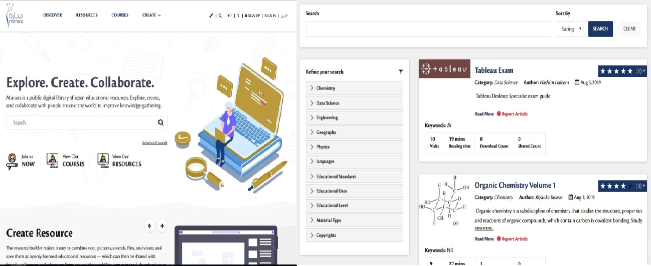

**Client Name – Sharjah Commerce and Tourism Development Authority (Government of Sharjah)**

Project Name: Permit Issuance and Inspection System

Contract Type: Fixed Bid

Location: Sharjah, U.A.E

Established in 1996, the Sharjah Commerce and Tourism Development Authority (SCTDA) is tasked with promoting commercial and tourism activities in the emirate of Sharjah. Sharjah intends to provide a sustainable tourism product with a unique and distinct tourism experience in the desert areas of the emirate. This is geared towards attracting the interest of various tourism companies, specifically tour operators, to focus on Sharjah when organizing desert trips and desert adventures activities within these areas. Consequently, this would be beneficial to the tourism sector and will contribute further to Sharjah’s economy. Hence, the Sharjah government has decided to organize desert tourism activities through this project; the issuance of permits to all tour vehicles entering the desert areas of Sharjah for desert safari activities owned or operated by tour operators along with the day to day inspection tasks carried by inspectors who can issue fines and attach evidences for further actions.

Sharjah Tourism resource deployment model comprises of Offsite resource (Verbat Resource) and Onsite Project Manager (from client’s side)

**Client Name – MBC**

Project Name: Security Inspection System

Contract Type: Fixed Bid

Location: Dubai, U.A.E

Smart Security System facilitates a sophisticated and structured approach to execute the daily security checklist to be used by the security patrol users. In addition to the ability of recording concern/issues as well to be viewed at any time as reports.  The application includes different users like Super Admin, Branch Admin, Inspector, Resolver and Viewer. The Inspector user reports patrol issues and concern issues using android mobile application. Branch admin assign the patrol issues to the resolver. Viewer will be able to see the issues and concerns related to the particular branch.

**Client Name – Carrefour Hybrid Project**

Project Name: Software Quality Assurance Managed Services

Contract Type: Time & Material

Resource Deployment Model: Hybrid (Onsite + Offsite)

Founded in 1992, Majid Al Futtaim is the leading shopping mall, retail and leisure pioneer across the Middle East and North Africa (MENA).

A remarkable business success story, Majid Al Futtaim started from one man’s vision to transform the face of shopping, entertainment and leisure to ‘create great moments for everyone, every day’. It has since grown into one of the United Arab Emirates’ most respected and successful businesses spanning 13 international markets, employing over 27,000 people, and achieving the highest credit rating (BBB) among privately-held corporates in the Middle East.

Carrefour testing team comprised of 20 resources inclusive of Onsite Project Manager, Onsite Test lead and Offsite Test Engineers

**Client Name – Ministry of Foreign Affairs**

Project Name: VISA Scheduling System

Contract Type: Fixed Bid

Location: Dubai, U.A.E

A web based application for the visa applicants and respected sponsors to schedule appointment for the security verifications. The system allows online payment facility. The application features include option for the sponsor to schedule appointments, option for the super admin to manage country and sites, manage other admin users and set e-mail/SMS notifications

# **ABOUT US**

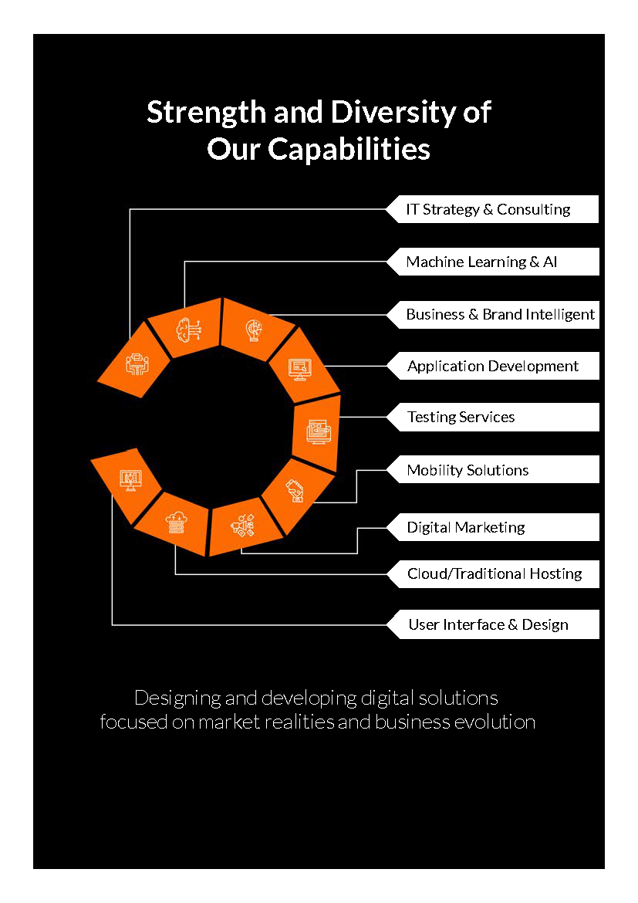

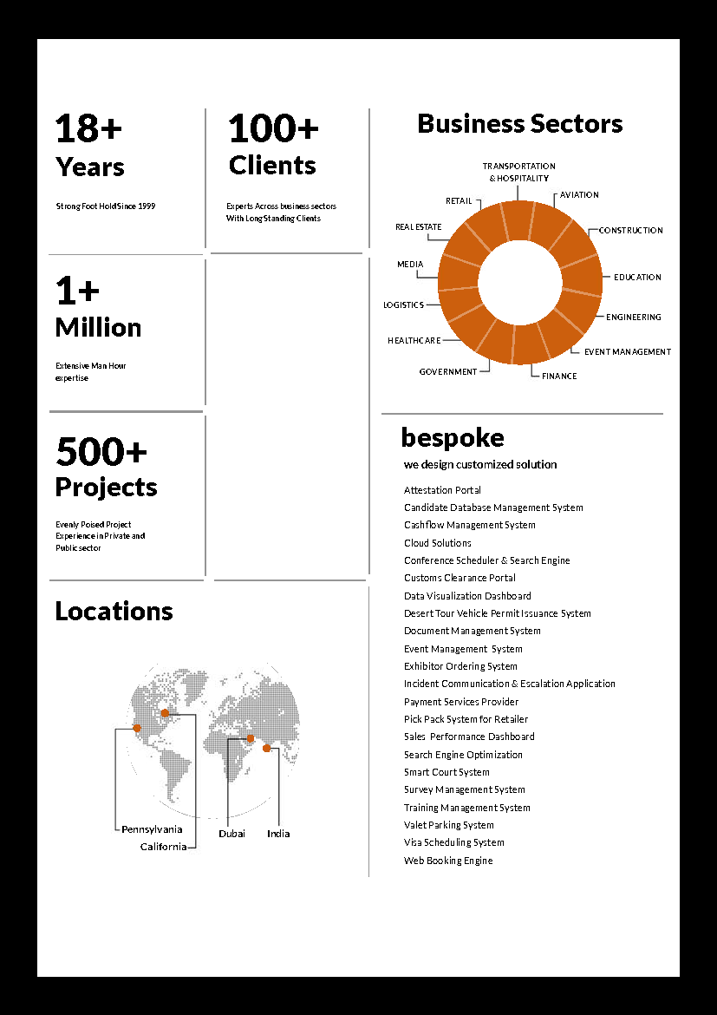



**Conﬁdentiality Notice:**

**This Proposal is conﬁdential and contains proprietary information and intellectual property of Verbanet Technologies LLC. Neither this proposal nor any of the information contained herein may be reproduced or disclosed under any circumstances without the express written permission of Verbanet Technologies L.L.C (hereby known under its brand name of Verbat in the United Arab Emirates). 2018. All rights Reserved**